目录

[501. Find Mode in Binary Search Tree 4](#_Toc57722014)

[502. IPO★★ 6](#_Toc57722015)

[503. Next Greater Element II★★ 8](#_Toc57722016)

[504. Base 7 9](#_Toc57722017)

[505. The Maze II 10](#_Toc57722018)

[506. Relative Ranks 14](#_Toc57722019)

[507. Perfect Number 16](#_Toc57722020)

[508. Most Frequent Subtree Sum 17](#_Toc57722021)

[509. Fibonacci Number 19](#_Toc57722022)

[510. Inorder Successor in BST II 21](#_Toc57722023)

[511. Game Play Analysis I（SQL） 25](#_Toc57722024)

[512. Game Play Analysis II（SQL） 27](#_Toc57722025)

[513. Find Bottom Left Tree Value 29](#_Toc57722026)

[514. Freedom Trail 31](#_Toc57722027)

[515. Find Largest Value in Each Tree Row 34](#_Toc57722028)

[516. Longest Palindromic Subsequence★★ 36](#_Toc57722029)

[517. Super Washing Machines★★ 38](#_Toc57722030)

[518. Coin Change 2 41](#_Toc57722031)

[519. Random Flip Matrix★★ 43](#_Toc57722032)

[520. Detect Capital 45](#_Toc57722033)

[521. Longest Uncommon Subsequence I 47](#_Toc57722034)

[522. Longest Uncommon Subsequence II 48](#_Toc57722035)

[523. Continuous Subarray Sum 50](#_Toc57722036)

[524. Longest Word in Dictionary through Deleting 52](#_Toc57722037)

[525. Contiguous Array 54](#_Toc57722038)

[526. Beautiful Arrangement 55](#_Toc57722039)

[527. Word Abbreviation 57](#_Toc57722040)

[528. Random Pick with Weight 58](#_Toc57722041)

[529. Minesweeper 60](#_Toc57722042)

[530. Minimum Absolute Difference in BST 64](#_Toc57722043)

[531. Lonely Pixel I 66](#_Toc57722044)

[532. K-diff Pairs in an Array 68](#_Toc57722045)

[533. Lonely Pixel II 70](#_Toc57722046)

[534. Game Play Analysis III（SQL） 73](#_Toc57722047)

[535. Encode and Decode TinyURL 76](#_Toc57722048)

[536. Construct Binary Tree from String 78](#_Toc57722049)

[537. Complex Number Multiplication 80](#_Toc57722050)

[538. Convert BST to Greater Tree 81](#_Toc57722051)

[539. Minimum Time Difference 83](#_Toc57722052)

[540. Single Element in a Sorted Array 85](#_Toc57722053)

[541. Reverse String II 87](#_Toc57722054)

[542. 01 Matrix 88](#_Toc57722055)

[543. Diameter of Binary Tree 90](#_Toc57722056)

[544. Output Contest Matches 92](#_Toc57722057)

[545. Boundary of Binary Tree★★ 95](#_Toc57722058)

[546. Remove Boxes★★ 98](#_Toc57722059)

[547. Friend Circles 100](#_Toc57722060)

[548. Split Array with Equal Sum★ 102](#_Toc57722061)

[549. Binary Tree Longest Consecutive Sequence II 104](#_Toc57722062)

[550. Game Play Analysis IV（SQL） 106](#_Toc57722063)

[551. Student Attendance Record I 108](#_Toc57722064)

[552. Student Attendance Record II 110](#_Toc57722065)

[553. Optimal Division 112](#_Toc57722066)

[554. Brick Wall 114](#_Toc57722067)

[555. Split Concatenated Strings 116](#_Toc57722068)

[556. Next Greater Element III 117](#_Toc57722069)

[557. Reverse Words in a String III 118](#_Toc57722070)

[558. Quad Tree Intersection 119](#_Toc57722071)

[559. Maximum Depth of N-ary Tree 123](#_Toc57722072)

[560. Subarray Sum Equals K 125](#_Toc57722073)

[561. Array Partition I 126](#_Toc57722074)

[562. Longest Line of Consecutive One in Matrix 127](#_Toc57722075)

[563. Binary Tree Tilt 129](#_Toc57722076)

[564. Find the Closest Palindrome 131](#_Toc57722077)

[565. Array Nesting 132](#_Toc57722078)

[566. Reshape the Matrix 134](#_Toc57722079)

[567. Permutation in String 136](#_Toc57722080)

[568. Maximum Vacation Days 138](#_Toc57722081)

[569. Median Employee Salary（SQL） 141](#_Toc57722082)

[570. Managers with at Least 5 Direct Reports（SQL） 143](#_Toc57722083)

[571. Find Median Given Frequency of Numbers(SQL) 144](#_Toc57722084)

[572. Subtree of Another Tree 145](#_Toc57722085)

[573. Squirrel Simulation 148](#_Toc57722086)

[574. Winning Candidate(SQL) 150](#_Toc57722087)

[575. Distribute Candies 152](#_Toc57722088)

[576. Out of Boundary Paths 154](#_Toc57722089)

[577. Employee Bonus(SQL) 157](#_Toc57722090)

[578. Get Highest Answer Rate Question 159](#_Toc57722091)

[579. Find Cumulative Salary of an Employee 161](#_Toc57722092)

[580. Count Student Number in Departments(SQL) 164](#_Toc57722093)

[581. Shortest Unsorted Continuous Subarray 166](#_Toc57722094)

[582. Kill Process 168](#_Toc57722095)

[583. Delete Operation for Two Strings 170](#_Toc57722096)

[584. Find Customer Referee(SQL) 172](#_Toc57722097)

[585. Investments in 2016 174](#_Toc57722098)

[586. Customer Placing the Largest Number of Orders 177](#_Toc57722099)

[587. Erect the Fence 179](#_Toc57722100)

[588. Design In-Memory File System 182](#_Toc57722101)

[589. N-ary Tree Preorder Traversal 185](#_Toc57722102)

[590. N-ary Tree Postorder Traversal★ 188](#_Toc57722103)

[591. Tag Validator★ 191](#_Toc57722104)

[592. Fraction Addition and Subtraction 196](#_Toc57722105)

[593. Valid Square 198](#_Toc57722106)

[594. Longest Harmonious Subsequence 200](#_Toc57722107)

[595. Big Countries(SQL) 201](#_Toc57722108)

[596. Classes More Than 5 Students(SQL) 202](#_Toc57722109)

[597. Friend Requests I: Overall Acceptance Rate(SQL) 204](#_Toc57722110)

[598. Range Addition II 206](#_Toc57722111)

[599. Minimum Index Sum of Two Lists 208](#_Toc57722112)

[600. Nonnegative Integers without Consecutive Ones★★ 210](#_Toc57722113)

### 501. Find Mode in Binary Search Tree

Easy

Given a binary search tree (BST) with duplicates, find all the [mode(s)](https://en.wikipedia.org/wiki/Mode_(statistics)) (the most frequently occurred element) in the given BST.

Assume a BST is defined as follows:

* The left subtree of a node contains only nodes with keys **less than or equal to** the node's key.
* The right subtree of a node contains only nodes with keys **greater than or equal to** the node's key.
* Both the left and right subtrees must also be binary search trees.

For example:  
Given BST [1,null,2,2],

1

\

2

/

2

return [2].

**Note:** If a tree has more than one mode, you can return them in any order.

**Follow up:** Could you do that without using any extra space? (Assume that the implicit stack space incurred due to recursion does not count).

/\*\*

\* Definition for a binary tree node.

\* struct TreeNode {

\* int val;

\* TreeNode \*left;

\* TreeNode \*right;

\* TreeNode(int x) : val(x), left(NULL), right(NULL) {}

\* };

\*/

class Solution {

public:

vector<int> findMode(TreeNode\* p) {

int cnt = 0, maxcnt = 0, cur = 0;

vector<int> res;

stack<TreeNode\*> stk;

while (!stk.empty() || p) {

while (p) {

stk.push(p);

p = p->left;

}

p = stk.top();

if (p->val != cur) {

cnt = 0;

cur = p->val;

}

if (++cnt > maxcnt) {

res.clear();

res.push\_back(cur);

maxcnt = cnt;

}

else if (cnt == maxcnt) res.push\_back(cur);

stk.pop();

p = p->right;

}

return res;

}

};

### 502. IPO★★

Hard

Suppose LeetCode will start its IPO soon. In order to sell a good price of its shares to Venture Capital, LeetCode would like to work on some projects to increase its capital before the IPO. Since it has limited resources, it can only finish at most **k** distinct projects before the IPO. Help LeetCode design the best way to maximize its total capital after finishing at most **k** distinct projects.

You are given several projects. For each project **i**, it has a pure profit **Pi** and a minimum capital of **Ci** is needed to start the corresponding project. Initially, you have **W** capital. When you finish a project, you will obtain its pure profit and the profit will be added to your total capital.

To sum up, pick a list of at most **k** distinct projects from given projects to maximize your final capital, and output your final maximized capital.

**Example 1:**

**Input:** k=2, W=0, Profits=[1,2,3], Capital=[0,1,1].

**Output:** 4

**Explanation:** Since your initial capital is 0, you can only start the project indexed 0.

After finishing it you will obtain profit 1 and your capital becomes 1.

With capital 1, you can either start the project indexed 1 or the project indexed 2.

Since you can choose at most 2 projects, you need to finish the project indexed 2 to get the maximum capital.

Therefore, output the final maximized capital, which is 0 + 1 + 3 = 4.

**Note:**

1. You may assume all numbers in the input are non-negative integers.
2. The length of Profits array and Capital array will not exceed 50,000.
3. The answer is guaranteed to fit in a 32-bit signed integer.

class Solution {

public:

    using pii = pair<int,int>;

    int findMaximizedCapital(int k,int W,vector<int>&p,vector<int>&c){

        vector<pii> v;

        for (int i = 0 ; i < p.size(); ++i) {

            if (p[i] > 0)

               v.emplace\_back(p[i], c[i]);

        }

        sort(v.begin(), v.end(), [&](const pii &a, const pii &b) {

            return a.second < b.second;

        });

        priority\_queue<int> pq;

        size\_t i = 0;

        while (k--) {

            while (i < v.size() && v[i].second <= W)

                pq.push(v[i++].first);

            if (!pq.empty()) {

                W += pq.top();

                pq.pop();

            }

        }

        return W;

    }

};

### 503. Next Greater Element II★★

Medium

Given a circular array (the next element of the last element is the first element of the array), print the Next Greater Number for every element. The Next Greater Number of a number x is the first greater number to its traversing-order next in the array, which means you could search circularly to find its next greater number. If it doesn't exist, output -1 for this number.

**Example 1:**

**Input:** [1,2,1]

**Output:** [2,-1,2]

**Explanation:** The first 1's next greater number is 2;   
The number 2 can't find next greater number;   
The second 1's next greater number needs to search circularly, which is also 2.

**Note:** The length of given array won't exceed 10000.

class Solution **{**

public**:**

vector**<**int**>** nextGreaterElements**(**vector**<**int**>&** nums**)** **{**

stack**<**int**>** stk**;**

int n **=** nums**.**size**();**

vector**<**int**>** res**(**n**,** **-**1**);**

**for(**int k **=** 0**;** k **<** 2**;** k**++)** **{**

**for** **(**int i **=** 0**;** i **<** n**;** i**++)** **{**

**while** **(!**stk**.**empty**()** **&&** nums**[**stk**.**top**()]** **<** nums**[**i**])** **{**

res**[**stk**.**top**()]** **=** nums**[**i**];**

stk**.**pop**();**

**}**

stk**.**push**(**i**);**

**}**

**}**

**return** res**;**

**}**

**};**

### 504. Base 7

Easy

Given an integer, return its base 7 string representation.

**Example 1:**

**Input:** 100

**Output:** "202"

**Example 2:**

**Input:** -7

**Output:** "-10"

**Note:** The input will be in range of [-1e7, 1e7].

class Solution **{**

public**:**

string convertToBase7**(**int num**)** **{**

**if** **(**num **==** 0**)** **return** "0"**;**

string res**;**

bool isNeg **=** num **<** 0**;**

**while** **(**num **!=** 0**)** **{**

res **+=** char**(**'0'**+**abs**(**num **%** 7**));**

num **/=** 7**;**

**}**

reverse**(**res**.**begin**(),** res**.**end**());**

**return** isNeg **?** '-' **+** res **:** res**;**

**}**

**};**

### [505. The Maze II](https://leetcode-cn.com/problems/the-maze-ii/)

There is a **ball** in a maze with empty spaces and walls. The ball can go through empty spaces by rolling **up**, **down**, **left** or **right**, but it won't stop rolling until hitting a wall. When the ball stops, it could choose the next direction.

Given the ball's **start position**, the **destination** and the **maze**, find the shortest distance for the ball to stop at the destination. The distance is defined by the number of **empty spaces** traveled by the ball from the start position (excluded) to the destination (included). If the ball cannot stop at the destination, return -1.

The maze is represented by a binary 2D array. 1 means the wall and 0 means the empty space. You may assume that the borders of the maze are all walls. The start and destination coordinates are represented by row and column indexes.

**Example 1:**

**Input 1:** a maze represented by a 2D array

0 0 1 0 0

0 0 0 0 0

0 0 0 1 0

1 1 0 1 1

0 0 0 0 0

**Input 2:** start coordinate (rowStart, colStart) = (0, 4)

**Input 3:** destination coordinate (rowDest, colDest) = (4, 4)

**Output:** 12

**Explanation:** One shortest way is : left -> down -> left -> down -> right -> down -> right.

The total distance is 1 + 1 + 3 + 1 + 2 + 2 + 2 = 12.

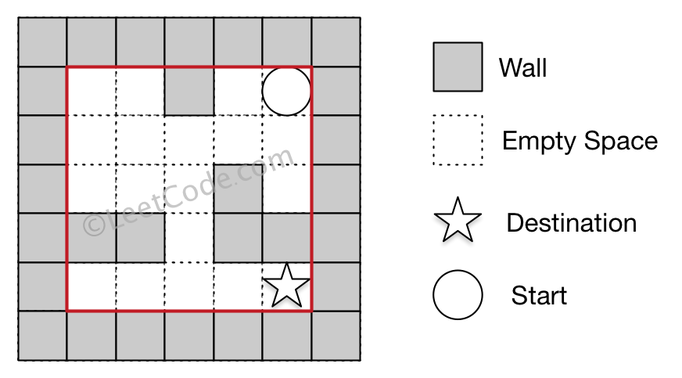

**Example 2:**

**Input 1:** a maze represented by a 2D array

0 0 1 0 0

0 0 0 0 0

0 0 0 1 0

1 1 0 1 1

0 0 0 0 0

**Input 2:** start coordinate (rowStart, colStart) = (0, 4)

**Input 3:** destination coordinate (rowDest, colDest) = (3, 2)

**Output:** -1

**Explanation:** There is no way for the ball to stop at the destination.

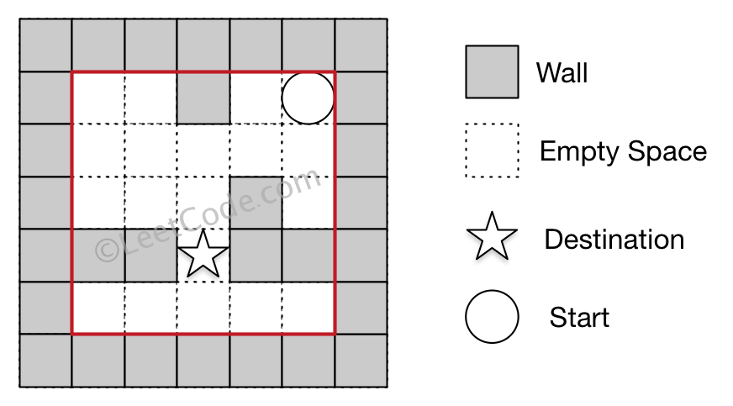

**Note:**

1. There is only one ball and one destination in the maze.
2. Both the ball and the destination exist on an empty space, and they will not be at the same position initially.
3. The given maze does not contain border (like the red rectangle in the example pictures), but you could assume the border of the maze are all walls.
4. The maze contains at least 2 empty spaces, and both the width and height of the maze won't exceed 100.

class Solution {

public:

    struct node {

        int x, y, cnt;

        node(int a, int b, int c) : x(a), y(b), cnt(c) {}

    };

    int shortestDistance(vector<vector<int>>& maze, vector<int>& start, vector<int>& destination) {

        int n = maze.size(), m = maze[0].size();

        vector<vector<int>> visit(n, vector<int>(m, INT\_MAX));

        int &res = visit[destination[0]][destination[1]];

        queue<node> pq;

        pq.emplace(start[0], start[1], 0);

        visit[start[0]][start[1]] = 0;

        while (!pq.empty()) {

            auto u = pq.front();

            pq.pop();

            for (int k = 0; k < 4; ++k) {

                int x = u.x, y = u.y, c = u.cnt;

                while (1) {

                    int xx = x + dx[k], yy = y + dy[k];

                    if (xx < 0 || yy < 0 || xx >= n || yy >= m

|| maze[xx][yy]) break;

                    x = xx; y = yy; ++c;

                }

                if (visit[x][y] <= c) continue;

                visit[x][y] = c;

                if (visit[x][y] < res) {

                    pq.emplace(x, y, c);

                }

            }

        }

        return res == INT\_MAX ? -1 : res;

    }

private:

    const vector<int> dx{0, 0, 1, -1};

    const vector<int> dy{1, -1, 0, 0};

};

### 506. Relative Ranks

Easy

Given scores of **N** athletes, find their relative ranks and the people with the top three highest scores, who will be awarded medals: "Gold Medal", "Silver Medal" and "Bronze Medal".

**Example 1:**

**Input:** [5, 4, 3, 2, 1]

**Output:** ["Gold Medal", "Silver Medal", "Bronze Medal", "4", "5"]

**Explanation:** The first three athletes got the top three highest scores, so they got "Gold Medal", "Silver Medal" and "Bronze Medal".   
For the left two athletes, you just need to output their relative ranks according to their scores.

**Note:**

1. N is a positive integer and won't exceed 10,000.
2. All the scores of athletes are guaranteed to be unique.

class Solution **{**

public**:**

vector**<**string**>** findRelativeRanks**(**vector**<**int**>&** nums**)** **{**

int n **=** nums**.**size**();**

map**<**int**,** int**>** mp**;**

**for** **(**int i **=** 0**;** i **<** n**;** i**++)** mp**[**nums**[**i**]]** **=** i**;**

vector**<**string**>** ans**(**n**);**

int cnt **=** 1**;**

**for** **(**map**<**int**,** int**>::**reverse\_iterator it **=** mp**.**rbegin**();** it **!=** mp**.**rend**();** it**++,** cnt**++)** **{**

**if** **(**cnt **==** 1**)** ans**[**it**->**second**]** **=** "Gold Medal"**;**

**else** **if** **(**cnt **==** 2**)** ans**[**it**->**second**]** **=** "Silver Medal"**;**

**else** **if** **(**cnt **==** 3**)** ans**[**it**->**second**]** **=** "Bronze Medal"**;**

**else** ans**[**it**->**second**]** **=** to\_string**(**cnt**);**

**}**

**return** ans**;**

**}**

**};**

### 507. Perfect Number

Easy

We define the Perfect Number is a **positive** integer that is equal to the sum of all its **positive** divisors except itself.

Now, given an **integer** n, write a function that returns true when it is a perfect number and false when it is not.

**Example:**

**Input:** 28

**Output:** True

**Explanation:** 28 = 1 + 2 + 4 + 7 + 14

**Note:** The input number **n** will not exceed 100,000,000. (1e8)

class Solution **{**

public**:**

bool checkPerfectNumber**(**int num**)** **{**

**if** **(**num **<=** 1**)** **return** **false;**

int sum **=** 0**,** Sqrt **=** sqrt**(**num**);**

**for** **(**int i **=** 1**;** i **<=** Sqrt**;** i**++)** **{**

**if** **(**num **%** i **==** 0**)** **{**

**if** **(**i **==** 1 **||** num**/**i **==** i**)** sum **+=** i**;**

**else** sum **+=** i **+** num**/**i**;**

**if** **(**sum **>** num**)** **break;**

**}**

**}**

**return** sum **==** num**;**

**}**

**};**

### 508. Most Frequent Subtree Sum

Medium

Given the root of a tree, you are asked to find the most frequent subtree sum. The subtree sum of a node is defined as the sum of all the node values formed by the subtree rooted at that node (including the node itself). So what is the most frequent subtree sum value? If there is a tie, return all the values with the highest frequency in any order.

**Examples 1**  
Input:

5

/ \

2 -3

return [2, -3, 4], since all the values happen only once, return all of them in any order.

**Examples 2**  
Input:

5

/ \

2 -5

return [2], since 2 happens twice, however -5 only occur once.

**Note:** You may assume the sum of values in any subtree is in the range of 32-bit signed integer.

/\*\*

\* Definition for a binary tree node.

\* struct TreeNode {

\* int val;

\* TreeNode \*left;

\* TreeNode \*right;

\* TreeNode(int x) : val(x), left(NULL), right(NULL) {}

\* };

\*/

class Solution **{**

public**:**

vector**<**int**>** findFrequentTreeSum**(**TreeNode**\*** root**)** **{**

dfs**(**root**);**

vector**<**int**>** res**;**

**for** **(**auto **&**i **:** m**)** **if** **(**i**.**second **==** MaxCnt**)** **{**

res**.**push\_back**(**i**.**first**);**

**}**

**return** res**;**

**}**

private**:**

unordered\_map**<**int**,** int**>** m**;**

int MaxCnt **=** 0**;**

int dfs**(**TreeNode **\***root**)** **{**

**if** **(!**root**)** **return** 0**;**

int l **=** dfs**(**root**->**left**),** r **=** dfs**(**root**->**right**);**

int ret **=** l **+** r **+** root**->**val**;**

MaxCnt **=** max**(**MaxCnt**,** **++**m**[**ret**]);**

**return** ret**;**

**}**

**};**

### 509. Fibonacci Number

Easy

The **Fibonacci numbers**, commonly denoted F(n) form a sequence, called the **Fibonacci sequence**, such that each number is the sum of the two preceding ones, starting from 0 and 1. That is,

F(0) = 0,   F(1) = 1

F(N) = F(N - 1) + F(N - 2), for N > 1.

Given N, calculate F(N).

**Example 1:**

**Input:** 2

**Output:** 1

**Explanation:** F(2) = F(1) + F(0) = 1 + 0 = 1.

**Example 2:**

**Input:** 3

**Output:** 2

**Explanation:** F(3) = F(2) + F(1) = 1 + 1 = 2.

**Example 3:**

**Input:** 4

**Output:** 3

**Explanation:** F(4) = F(3) + F(2) = 2 + 1 = 3.

**Note:**

0 ≤ N ≤ 30.

class Solution **{**

public**:**

struct Matrix**{**

int a**[**2**][**2**]** **=** **{**0**};**

void init**(){**

**for** **(**int i **=** 0**;** i **<** 2**;** i**++)**

a**[**i**][**i**]** **=** 1**;**

**}**

**};**

Matrix MUL**(**Matrix A**,** Matrix B**){**

Matrix C**;**

**for** **(**int i **=** 0**;** i **<** 2**;** i**++)** **{**

**for** **(**int j **=** 0**;** j **<** 2**;** j**++)** **{**

**for** **(**int k **=** 0**;** k **<** 2**;** k**++){**

C**.**a**[**i**][**j**]** **+=** A**.**a**[**i**][**k**]** **\*** B**.**a**[**k**][**j**];**

**}**

**}**

**}**

**return** C**;**

**}**

int fib**(**int n**)** **{**

Matrix res**,** x**;**

x**.**a**[**0**][**0**]** **=** x**.**a**[**0**][**1**]** **=** x**.**a**[**1**][**0**]** **=** 1**;**

x**.**a**[**1**][**1**]** **=** 0**;**

res**.**init**();**

**while** **(**n**)** **{**

**if** **(**n**&**1**)** res **=** MUL**(**res**,** x**);**

x **=** MUL**(**x**,** x**);**

n **>>=** 1**;**

**}**

**return** res**.**a**[**1**][**0**];**

**}**

**};**

### [510. Inorder Successor in BST II](https://leetcode-cn.com/problems/inorder-successor-in-bst-ii/)

Given a node in a binary search tree, find the in-order successor of that node in the BST.

If that node has no in-order successor, return null.

The successor of a node is the node with the smallest key greater than node.val.

You will have direct access to the node but not to the root of the tree. Each node will have a reference to its parent node. Below is the definition for Node:

class Node {

public int val;

public Node left;

public Node right;

public Node parent;

}

**Follow up:**

Could you solve it without looking up any of the node's values?

**Example 1:**

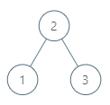

**Input:** tree = [2,1,3], node = 1

**Output:** 2

**Explanation:** 1's in-order successor node is 2. Note that both the node and the return value is of Node type.

**Example 2:**

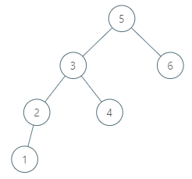

**Input:** tree = [5,3,6,2,4,null,null,1], node = 6

**Output:** null

**Explanation:** There is no in-order successor of the current node, so the answer is null.

**Example 3:**

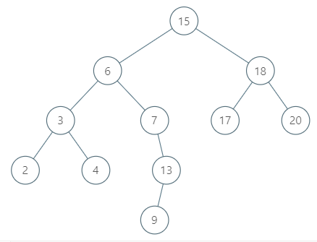

**Input:** tree = [15,6,18,3,7,17,20,2,4,null,13,null,null,null,null,null,null,null,null,9], node = 15

**Output:** 17

**Example 4:**



**Input:** tree = [15,6,18,3,7,17,20,2,4,null,13,null,null,null,null,null,null,null,null,9], node = 13

**Output:** 15

**Example 5:**

**Input:** tree = [0], node = 0

**Output:** null

**Constraints:**

* -10^5 <= Node.val <= 10^5
* 1 <= Number of Nodes <= 10^4
* All Nodes will have unique values.

/\*

// Definition for a Node.

class Node {

public:

    int val;

    Node\* left;

    Node\* right;

    Node\* parent;

};

\*/

class Solution {

public:

    Node\* inorderSuccessor(Node\* node) {

        if (node->right) {

            node = node->right;

            while (node->left) node = node->left;

            return node;

        }

        else {

            while (node->parent) {

                auto p = node->parent;

                if (p->left == node) return p;

                node = p;

            }

            return nullptr;

        }

    }

};

### [511. Game Play Analysis I](https://leetcode-cn.com/problems/game-play-analysis-i/)（SQL）

难度简单9收藏分享切换为中文关注反馈

SQL架构

Table: Activity

+--------------+---------+

| Column Name | Type |

+--------------+---------+

| player\_id | int |

| device\_id | int |

| event\_date | date |

| games\_played | int |

+--------------+---------+

(player\_id, event\_date) is the primary key of this table.

This table shows the activity of players of some game.

Each row is a record of a player who logged in and played a number of games (possibly 0) before logging out on some day using some device.

Write an SQL query that reports the **first login date** for each player.

The query result format is in the following example:

Activity table:

+-----------+-----------+------------+--------------+

| player\_id | device\_id | event\_date | games\_played |

+-----------+-----------+------------+--------------+

| 1 | 2 | 2016-03-01 | 5 |

| 1 | 2 | 2016-05-02 | 6 |

| 2 | 3 | 2017-06-25 | 1 |

| 3 | 1 | 2016-03-02 | 0 |

| 3 | 4 | 2018-07-03 | 5 |

+-----------+-----------+------------+--------------+

Result table:

+-----------+-------------+

| player\_id | first\_login |

+-----------+-------------+

| 1 | 2016-03-01 |

| 2 | 2017-06-25 |

| 3 | 2016-03-02 |

+-----------+-------------+

select player\_id, min(event\_date) as 'first\_login'

from Activity

group by player\_id

### [512. Game Play Analysis II](https://leetcode-cn.com/problems/game-play-analysis-ii/)（SQL）

SQL架构

Table: Activity

+--------------+---------+

| Column Name | Type |

+--------------+---------+

| player\_id | int |

| device\_id | int |

| event\_date | date |

| games\_played | int |

+--------------+---------+

(player\_id, event\_date) is the primary key of this table.

This table shows the activity of players of some game.

Each row is a record of a player who logged in and played a number of games (possibly 0) before logging out on some day using some device.

Write a SQL query that reports the **device** that is first logged in for each player.

The query result format is in the following example:

Activity table:

+-----------+-----------+------------+--------------+

| player\_id | device\_id | event\_date | games\_played |

+-----------+-----------+------------+--------------+

| 1 | 2 | 2016-03-01 | 5 |

| 1 | 2 | 2016-05-02 | 6 |

| 2 | 3 | 2017-06-25 | 1 |

| 3 | 1 | 2016-03-02 | 0 |

| 3 | 4 | 2018-07-03 | 5 |

+-----------+-----------+------------+--------------+

Result table:

+-----------+-----------+

| player\_id | device\_id |

+-----------+-----------+

| 1 | 2 |

| 2 | 3 |

| 3 | 1 |

+-----------+-----------+

select player\_id, device\_id

from Activity

where (player\_id, event\_date) in (select player\_id, min(event\_date)

                                from Activity

                                group by player\_id)

### 513. Find Bottom Left Tree Value

Medium

Given a binary tree, find the leftmost value in the last row of the tree.

**Example 1:**

Input:

2

/ \

1 3

Output:

1

**Example 2:**

Input:

1

/ \

2 3

/ / \

4 5 6

/

7

Output:

7

/\*\*

\* Definition for a binary tree node.

\* struct TreeNode {

\* int val;

\* TreeNode \*left;

\* TreeNode \*right;

\* TreeNode(int x) : val(x), left(NULL), right(NULL) {}

\* };

\*/

class Solution **{**

public**:**

int findBottomLeftValue**(**TreeNode**\*** root**)** **{**

queue**<**TreeNode**\*>** que**;**

que**.**push**(**root**);**

TreeNode **\***t**;**

**while** **(!**que**.**empty**())** **{**

t **=** que**.**front**();**

que**.**pop**();**

**if** **(**t**->**right**)** que**.**push**(**t**->**right**);**

**if** **(**t**->**left**)** que**.**push**(**t**->**left**);**

**}**

**return** t**->**val**;**

**}**

**};**

### 514. Freedom Trail

Hard

In the video game Fallout 4, the quest "Road to Freedom" requires players to reach a metal dial called the "Freedom Trail Ring", and use the dial to spell a specific keyword in order to open the door.

Given a string **ring**, which represents the code engraved on the outer ring and another string **key**, which represents the keyword needs to be spelled. You need to find the **minimum** number of steps in order to spell all the characters in the keyword.

Initially, the first character of the **ring** is aligned at 12:00 direction. You need to spell all the characters in the string **key** one by one by rotating the ring clockwise or anticlockwise to make each character of the string **key** aligned at 12:00 direction and then by pressing the center button.

At the stage of rotating the ring to spell the key character **key[i]**:

1. You can rotate the **ring** clockwise or anticlockwise **one place**, which counts as 1 step. The final purpose of the rotation is to align one of the string **ring's** characters at the 12:00 direction, where this character must equal to the character **key[i]**.
2. If the character **key[i]** has been aligned at the 12:00 direction, you need to press the center button to spell, which also counts as 1 step. After the pressing, you could begin to spell the next character in the key (next stage), otherwise, you've finished all the spelling.

**Example:**

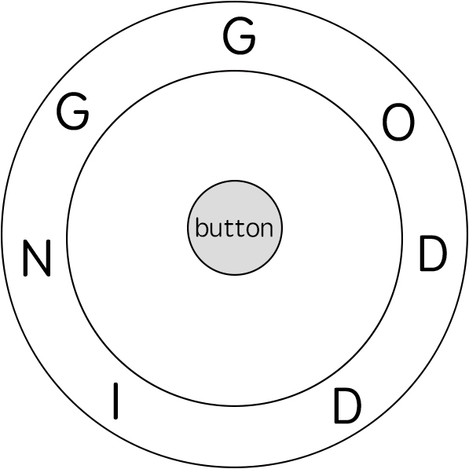

**Input:** ring = "godding", key = "gd"

**Output:** 4

**Explanation:**

For the first key character 'g', since it is already in place, we just need 1 step to spell this character.

For the second key character 'd', we need to rotate the ring "godding" anticlockwise by two steps to make it become "ddinggo".

Also, we need 1 more step for spelling.

So the final output is 4.

**Note:**

1. Length of both ring and **key** will be in range 1 to 100.
2. There are only lowercase letters in both strings and might be some duplcate characters in both strings.
3. It's guaranteed that string **key** could always be spelled by rotating the string **ring**.

class Solution {

public:

int findRotateSteps(string ring, string key) {

unordered\_map<char, vector<int>> mp;

int n = ring.size();

for (int i = 0; i < n; ++i) mp[ring[i]].push\_back(i);

vector<vector<pair<int, int>>> dp(2);

dp[0].push\_back({0, 0});

int k = 0;

for (auto c : key) {

vector<pair<int, int>> &cur = dp[k^1], &pre = dp[k];

cur.clear();

for (auto pos : mp[c]) {

int step = INT\_MAX;

for (auto &pii : pre) {

step = min(step, pii.second + dist(pii.first, pos, n));

}

cur.push\_back({pos, step});

}

k ^= 1;

}

int res = INT\_MAX;

for (auto &pii : dp[k]) {

res = min(res, pii.second);

}

return res + key.size();

}

private:

int dist(int i, int j, int n) {

int t = (i-j+n) % n;

return min(t, n-t);

}

};

### 515. Find Largest Value in Each Tree Row

Medium

You need to find the largest value in each row of a binary tree.

**Example:**

**Input:**

1

/ \

3 2

/ \ \

5 3 9

**Output:** [1, 3, 9]

/\*\*

\* Definition for a binary tree node.

\* struct TreeNode {

\* int val;

\* TreeNode \*left;

\* TreeNode \*right;

\* TreeNode(int x) : val(x), left(NULL), right(NULL) {}

\* };

\*/

class Solution **{**

public**:**

vector**<**int**>** largestValues**(**TreeNode**\*** root**)** **{**

vector**<**int**>** res**;**

**if** **(!**root**)** **return** res**;**

queue**<**TreeNode**\*>** que**;**

que**.**push**(**root**);**

**while** **(!**que**.**empty**())** **{**

int Max **=** que**.**front**()->**val**,** sz **=** que**.**size**();**

**while** **(**sz**--)** **{**

auto t **=** que**.**front**();**

**if** **(**t**->**left**)** que**.**push**(**t**->**left**);**

**if** **(**t**->**right**)** que**.**push**(**t**->**right**);**

que**.**pop**();**

Max **=** max**(**Max**,** t**->**val**);**

**}**

res**.**push\_back**(**Max**);**

**}**

**return** res**;**

**}**

**};**

### 516. Longest Palindromic Subsequence★★

Medium

Given a string s, find the longest palindromic subsequence's length in s. You may assume that the maximum length of s is 1000.

**Example 1:**  
Input:

"bbbab"

Output:

4

One possible longest palindromic subsequence is "bbbb".

**Example 2:**  
Input:

"cbbd"

Output:

2

One possible longest palindromic subsequence is "bb".

class Solution **{**

public**:**

int longestPalindromeSubseq**(**string s**)** **{**

int n **=** s**.**size**();**

vector**<**vector**<**int**>>** dp**(**n**,** vector**<**int**>(**n**));**

**for** **(**int i **=** n **-** 1**;** i **>=** 0**;** **--**i**)** **{**

dp**[**i**][**i**]** **=** 1**;**

**for** **(**int j **=** i **+** 1**;** j **<** n**;** **++**j**)** **{**

**if** **(**s**[**i**]** **==** s**[**j**])** **{**

dp**[**i**][**j**]** **=** dp**[**i **+** 1**][**j **-** 1**]** **+** 2**;**

**}** **else** **{**

dp**[**i**][**j**]** **=** max**(**dp**[**i **+** 1**][**j**],** dp**[**i**][**j **-** 1**]);**

**}**

**}**

**}**

**return** dp**[**0**][**n **-** 1**];**

**}**

**};**

### 517. Super Washing Machines★★

Hard

You have **n** super washing machines on a line. Initially, each washing machine has some dresses or is empty.

For each **move**, you could choose **any m** (1 ≤ m ≤ n) washing machines, and pass **one dress** of each washing machine to one of its adjacent washing machines **at the same time** .

Given an integer array representing the number of dresses in each washing machine from left to right on the line, you should find the **minimum number of moves** to make all the washing machines have the same number of dresses. If it is not possible to do it, return -1.

**Example1**

**Input:** [1,0,5]

**Output:** 3

**Explanation:**

1st move: 1 0 <-- 5 => 1 1 4

2nd move: 1 <-- 1 <-- 4 => 2 1 3

3rd move: 2 1 <-- 3 => 2 2 2

**Example2**

**Input:** [0,3,0]

**Output:** 2

**Explanation:**

1st move: 0 <-- 3 0 => 1 2 0

2nd move: 1 2 --> 0 => 1 1 1

**Example3**

**Input:** [0,2,0]

**Output:** -1

**Explanation:**

It's impossible to make all the three washing machines have the same number of dresses.

**Note:**

1. The range of n is [1, 10000].
2. The range of dresses number in a super washing machine is [0, 1e5].

class Solution {

public:

    using ll = long long;

    int findMinMoves(vector<int>& v) {

        int n = v.size();

        ll sum = accumulate(v.begin(), v.end(), 0ll);

        if (sum % n != 0) return -1;

        int avg = sum/n;

        int currSum = 0, maxSum = 0, res = 0;

        for (auto m : v) {

            m -= avg;

            currSum += m;

            maxSum = max(maxSum, abs(currSum));

            res = max(res, max(maxSum, m));

        }

        return res;

    }

};

### 518. Coin Change 2

Medium

You are given coins of different denominations and a total amount of money. Write a function to compute the number of combinations that make up that amount. You may assume that you have infinite number of each kind of coin.

**Example 1:**

**Input:** amount = 5, coins = [1, 2, 5]

**Output:** 4

**Explanation:** there are four ways to make up the amount:

5=5

5=2+2+1

5=2+1+1+1

5=1+1+1+1+1

**Example 2:**

**Input:** amount = 3, coins = [2]

**Output:** 0

**Explanation:** the amount of 3 cannot be made up just with coins of 2.

**Example 3:**

**Input:** amount = 10, coins = [10]

**Output:** 1

**Note:**

You can assume that

* 0 <= amount <= 5000
* 1 <= coin <= 5000
* the number of coins is less than 500
* the answer is guaranteed to fit into signed 32-bit integer

class Solution **{**

public**:**

int change**(**int amount**,** vector**<**int**>&** coins**)** **{**

vector**<**int**>** dp**(**amount**+**1**,** 0**);**

dp**[**0**]** **=** 1**;**

**for** **(**auto **&**i **:** coins**)** **{**

**for** **(**int s **=** i**;** s **<=** amount**;** **++**s**)** **{**

dp**[**s**]** **+=** dp**[**s**-**i**];**

**}**

**}**

**return** dp**[**amount**];**

**}**

**};**

### 519. Random Flip Matrix★★

Medium

You are given the number of rows n\_rows and number of columns n\_cols of a 2D binary matrix where all values are initially 0. Write a function flip which chooses a 0 value [uniformly at random](https://en.wikipedia.org/wiki/Discrete_uniform_distribution" \t "_blank), changes it to 1, and then returns the position [row.id, col.id] of that value. Also, write a function reset which sets all values back to 0. **Try to minimize the number of calls to system's Math.random()** and optimize the time and space complexity.

Note:

1. 1 <= n\_rows, n\_cols <= 10000
2. 0 <= row.id < n\_rows and 0 <= col.id < n\_cols
3. flip will not be called when the matrix has no 0 values left.
4. the total number of calls to flip and reset will not exceed 1000.

**Example 1:**

**Input:**

["Solution","flip","flip","flip","flip"]

[[2,3],[],[],[],[]]

**Output:** [null,[0,1],[1,2],[1,0],[1,1]]

**Example 2:**

**Input:**

["Solution","flip","flip","reset","flip"]

[[1,2],[],[],[],[]]

**Output:** [null,[0,0],[0,1],null,[0,0]]

**Explanation of Input Syntax:**

The input is two lists: the subroutines called and their arguments. Solution's constructor has two arguments, n\_rows and n\_cols. flip and reset have no arguments. Arguments are always wrapped with a list, even if there aren't any.

class Solution **{**

public**:**

Solution**(**int n\_rows**,** int n\_cols**)** **:** n**(**n\_rows**),** m**(**n\_cols**)** **{**

reset**();**

**}**

vector**<**int**>** flip**()** **{**

int used\_id **=** rand**()** **%** **(**sz**--);**

int unused\_id **=** mp**.**count**(**used\_id**)** **?** mp**[**used\_id**]** **:** used\_id**;**

mp**[**used\_id**]** **=** mp**.**count**(**sz**)** **?** mp**[**sz**]** **:** sz**;**

**return** **{**unused\_id **/** m**,** unused\_id **%** m**};**

**}**

void reset**()** **{**

mp**.**clear**();**

sz **=** n **\*** m**;**

**}**

private**:**

int n**,** m**,** sz**;**

unordered\_map**<**int**,** int**>** mp**;** //<used, not used>

**};**

/\*\*

\* Your Solution object will be instantiated and called as such:

\* Solution\* obj = new Solution(n\_rows, n\_cols);

\* vector<int> param\_1 = obj->flip();

\* obj->reset();

\*/

### 520. Detect Capital

Easy

Given a word, you need to judge whether the usage of capitals in it is right or not.

We define the usage of capitals in a word to be right when one of the following cases holds:

1. All letters in this word are capitals, like "USA".
2. All letters in this word are not capitals, like "leetcode".
3. Only the first letter in this word is capital, like "Google".

Otherwise, we define that this word doesn't use capitals in a right way.

**Example 1:**

**Input:** "USA"

**Output:** True

**Example 2:**

**Input:** "FlaG"

**Output:** False

**Note:** The input will be a non-empty word consisting of uppercase and lowercase latin letters.

class Solution **{**

public**:**

bool detectCapitalUse**(**string a**)** **{**

**for(**int i **=** 1**;** i **<** a**.**size**();** i**++)** **{**

**if** **(**isupper**(**a**[**1**])** **!=** isupper**(**a**[**i**])**

**||** islower**(**a**[**0**])** **&&** isupper**(**a**[**i**]))**

**return** **false;**

**}**

**return** **true;**

**}**

**};**

### 521. Longest Uncommon Subsequence I

Easy

Given a group of two strings, you need to find the longest uncommon subsequence of this group of two strings. The longest uncommon subsequence is defined as the longest subsequence of one of these strings and this subsequence should not be **any** subsequence of the other strings.

A **subsequence** is a sequence that can be derived from one sequence by deleting some characters without changing the order of the remaining elements. Trivially, any string is a subsequence of itself and an empty string is a subsequence of any string.

The input will be two strings, and the output needs to be the length of the longest uncommon subsequence. If the longest uncommon subsequence doesn't exist, return -1.

**Example 1:**

**Input:** "aba", "cdc"

**Output:** 3

**Explanation:** The longest uncommon subsequence is "aba" (or "cdc"),   
because "aba" is a subsequence of "aba",   
but not a subsequence of any other strings in the group of two strings.

**Note:**

1. Both strings' lengths will not exceed 100.
2. Only letters from a ~ z will appear in input strings.

class Solution **{**

public**:**

int findLUSlength**(**string a**,** string b**)** **{**

**if** **(**a **==** b**)** **return** **-**1**;**

**else** **return** max**(**a**.**size**(),** b**.**size**());**

**}**

**};**

### 522. Longest Uncommon Subsequence II

Medium

Given a list of strings, you need to find the longest uncommon subsequence among them. The longest uncommon subsequence is defined as the longest subsequence of one of these strings and this subsequence should not be **any** subsequence of the other strings.

A **subsequence** is a sequence that can be derived from one sequence by deleting some characters without changing the order of the remaining elements. Trivially, any string is a subsequence of itself and an empty string is a subsequence of any string.

The input will be a list of strings, and the output needs to be the length of the longest uncommon subsequence. If the longest uncommon subsequence doesn't exist, return -1.

**Example 1:**

**Input:** "aba", "cdc", "eae"

**Output:** 3

**Note:**

1. All the given strings' lengths will not exceed 10.
2. The length of the given list will be in the range of [2, 50].

class Solution **{**

public**:**

int findLUSlength**(**vector**<**string**>&** strs**)** **{**

int n **=** strs**.**size**();**

unordered\_set**<**string**>** s**;**

sort**(**strs**.**begin**(),** strs**.**end**(),** **[](**string a**,** string b**){**

**if** **(**a**.**size**()** **==** b**.**size**())** **return** a **>** b**;**

**return** a**.**size**()** **>** b**.**size**();**

**});**

**for** **(**int i **=** 0**;** i **<** n**;** **++**i**)** **{**

**if** **(**i **==** n**-**1 **||** strs**[**i**]** **!=** strs**[**i**+**1**])** **{**

bool found **=** **true;**

**for** **(**auto **&**a **:** s**)** **{**

int j **=** 0**;**

**for** **(**char c **:** a**)** **{**

**if** **(**c **==** strs**[**i**][**j**])** **++**j**;**

**if** **(**j **==** strs**[**i**].**size**())** **break;**

**}**

**if** **(**j **==** strs**[**i**].**size**())** **{**

found **=** **false;**

**break;**

**}**

**}**

**if** **(**found**)** **return** strs**[**i**].**size**();**

**}**

s**.**insert**(**strs**[**i**]);**

**}**

**return** **-**1**;**

**}**

**};**

### 523. Continuous Subarray Sum

Medium

Given a list of **non-negative** numbers and a target **integer** k, write a function to check if the array has a continuous subarray of size at least 2 that sums up to a multiple of **k**, that is, sums up to n\*k where n is also an **integer**.

**Example 1:**

**Input:** [23, 2, 4, 6, 7], k=6

**Output:** True

**Explanation:** Because [2, 4] is a continuous subarray of size 2 and sums up to 6.

**Example 2:**

**Input:** [23, 2, 6, 4, 7], k=6

**Output:** True

**Explanation:** Because [23, 2, 6, 4, 7] is an continuous subarray of size 5 and sums up to 42.

**Note:**

1. The length of the array won't exceed 10,000.
2. You may assume the sum of all the numbers is in the range of a signed 32-bit integer.

class Solution **{**

public**:**

bool checkSubarraySum**(**vector**<**int**>&** nums**,** int k**)** **{**

int n **=** nums**.**size**(),** sum **=** 0**;**

unordered\_map**<**int**,** int**>** modk**;**

modk**[**0**]** **=** **-**1**;**

**for** **(**int i **=** 0**;** i **<** n**;** **++**i**)** **{**

sum **+=** nums**[**i**];**

// 特例 k == 0

int mod **=** k **==** 0 **?** sum **:** sum **%** k**;**

**if** **(**modk**.**count**(**mod**))** **{**

**if** **(**modk**[**mod**]** **!=** i**-**1**)** **return** **true;**

**}**

**else** modk**[**mod**]** **=** i**;**

**}**

**return** **false;**

**}**

**};**

### 524. Longest Word in Dictionary through Deleting

Medium

Given a string and a string dictionary, find the longest string in the dictionary that can be formed by deleting some characters of the given string. If there are more than one possible results, return the longest word with the smallest lexicographical order. If there is no possible result, return the empty string.

**Example 1:**

**Input:**

s = "abpcplea", d = ["ale","apple","monkey","plea"]

**Output:**

"apple"

**Example 2:**

**Input:**

s = "abpcplea", d = ["a","b","c"]

**Output:**

"a"

**Note:**

1. All the strings in the input will only contain lower-case letters.
2. The size of the dictionary won't exceed 1,000.
3. The length of all the strings in the input won't exceed 1,000.

class Solution {

public:

    string findLongestWord(string s, vector<string>& d) {

        string res = "{";

        for (const auto &a : d) {

           if ((res.length() < a.length()

|| res.length() == a.length() && res > a) && check(a, s)) {

                 res = a;

           }

        }

        return res == "{" ? "" : res;

    }

private:

    bool check(const string &a, const string &s) {

        auto i = a.begin(), j = s.begin();

        while (i != a.end() && j != s.end()) {

            if (\*i == \*j) ++i;

            ++j;

        }

        return i == a.end();

    }

};

### 525. Contiguous Array

Medium

Given a binary array, find the maximum length of a contiguous subarray with equal number of 0 and 1.

**Example 1:**

**Input:** [0,1]

**Output:** 2

**Explanation:** [0, 1] is the longest contiguous subarray with equal number of 0 and 1.

**Example 2:**

**Input:** [0,1,0]

**Output:** 2

**Explanation:** [0, 1] (or [1, 0]) is a longest contiguous subarray with equal number of 0 and 1.

**Note:** The length of the given binary array will not exceed 50,000.

class Solution **{**

public**:**

int findMaxLength**(**vector**<**int**>&** nums**)** **{**

int n **=** nums**.**size**(),** res **=** 0**,** sum **=** 0**;**

unordered\_map**<**int**,** int**>** mp**{{**0**,** **-**1**}};**

**for** **(**int i **=** 0**;** i **<** n**;** **++**i**){**

nums**[**i**]** **==** 0 **?** **++**sum **:** **--**sum**;**

**if** **(**mp**.**count**(-**sum**))** res **=** max**(**res**,** i**-**mp**[-**sum**]);**

**else** mp**[-**sum**]** **=** i**;**

**}**

**return** res**;**

**}**

**};**

### 526. Beautiful Arrangement

Medium

Suppose you have **N** integers from 1 to N. We define a beautiful arrangement as an array that is constructed by these **N** numbers successfully if one of the following is true for the ith position (1 <= i <= N) in this array:

1. The number at the ith position is divisible by **i**.
2. **i** is divisible by the number at the ith position.

Now given N, how many beautiful arrangements can you construct?

**Example 1:**

**Input:** 2

**Output:** 2

**Explanation:**

The first beautiful arrangement is [1, 2]:

Number at the 1st position (i=1) is 1, and 1 is divisible by i (i=1).

Number at the 2nd position (i=2) is 2, and 2 is divisible by i (i=2).

The second beautiful arrangement is [2, 1]:

Number at the 1st position (i=1) is 2, and 2 is divisible by i (i=1).

Number at the 2nd position (i=2) is 1, and i (i=2) is divisible by 1.

**Note:**

1. **N** is a positive integer and will not exceed 15.

class Solution {

public:

int countArrangement(int N) {

vector<int> nums;

for(int i = 0; i < N; i++) nums.push\_back(i+1);

return dfs(0, N, nums);

}

private:

int dfs(int i, int n, vector<int> &nums) {

if (i == n) return 1;

int res = 0;

for (int j = i; j < n; ++j) {

if (nums[j] % (i+1) == 0 || (i+1) % nums[j] == 0) {

swap(nums[i],nums[j]);

res += dfs(i+1, n, nums);

swap(nums[i],nums[j]);

}

}

return res;

}

};

### [527. Word Abbreviation](https://leetcode-cn.com/problems/word-abbreviation/)★★

Given an array of n distinct non-empty strings, you need to generate **minimal** possible abbreviations for every word following rules below.

1. Begin with the first character and then the number of characters abbreviated, which followed by the last character.
2. If there are any conflict, that is more than one words share the same abbreviation, a longer prefix is used instead of only the first character until making the map from word to abbreviation become unique. In other words, a final abbreviation cannot map to more than one original words.
3. If the abbreviation doesn't make the word shorter, then keep it as original.

**Example:**

**Input:** ["like", "god", "internal", "me", "internet", "interval", "intension", "face", "intrusion"]

**Output:** ["l2e","god","internal","me","i6t","interval","inte4n","f2e","intr4n"]

**Note:**

1. Both n and the length of each word will not exceed 400.
2. The length of each word is greater than 1.
3. The words consist of lowercase English letters only.
4. The return answers should be **in the same order** as the original array.

class Trie {

public:

void insert(const string& s) {

Trie\* p = this;

for (auto c : s) {

if(!p->next.count(c)) p->next[c] = new Trie();

p = p->next[c]; p->freq++;

}

}

unordered\_map<char, Trie\*> next;

int freq = 0;

};

class Solution {

public:

vector<string> wordsAbbreviation(vector<string>& dict) {

unordered\_map<string, vector<int>> group;

for(int i = 0; i < dict.size(); ++i) {

string g = dict[i][0] + to\_string(dict[i].size())

+ dict[i].back();

group[g].push\_back(i);

}

vector<string> res(dict.size());

for (auto& g : group) {

Trie\* trie = new Trie();

for(auto& id : g.second) trie->insert(dict[id]);

for(auto& id : g.second) {

Trie\* cur = trie;

string temp, &s = dict[id];

for(int i = 0; i < s.size(); ++i) {

char c = s[i];

if (cur->next[c]->freq == 1) {

int cnt = s.size()-i-2;

if (cnt < 2) temp = s;

else temp=s.substr(0,i+1)+to\_string(cnt)+s.back();

break;

}

cur = cur->next[c];

}

res[id] = temp;

}

}

return res;

}

};

### 528. Random Pick with Weight

Medium

Given an array w of positive integers, where w[i] describes the weight of index i, write a function pickIndex which randomly picks an index in proportion to its weight.

Note:

1. 1 <= w.length <= 10000
2. 1 <= w[i] <= 10^5
3. pickIndex will be called at most 10000 times.

**Example 1:**

**Input:**

["Solution","pickIndex"]

[[[1]],[]]

**Output:** [null,0]

**Example 2:**

**Input:**

["Solution","pickIndex","pickIndex","pickIndex","pickIndex","pickIndex"]

[[[1,3]],[],[],[],[],[]]

**Output:** [null,0,1,1,1,0]

**Explanation of Input Syntax:**

The input is two lists: the subroutines called and their arguments. Solution's constructor has one argument, the array w. pickIndex has no arguments. Arguments are always wrapped with a list, even if there aren't any.

class Solution {

public:

    vector<int> v;

    int sum = 0;

    //c++11 random integer generation

    default\_random\_engine e;

    uniform\_int\_distribution<int> uni;

    Solution(vector<int> w) {

        for (int x : w) {

            v.push\_back(sum += x);

        }

        uni = uniform\_int\_distribution<int>{0, sum - 1};

    }

    int pickIndex() {

        int targ = uni(e);

        return upper\_bound(v.begin(), v.end(), targ) - v.begin();

    }

};

### 529. Minesweeper

Medium

Let's play the minesweeper game ([Wikipedia](https://en.wikipedia.org/wiki/Minesweeper_(video_game)), [online game](http://minesweeperonline.com/))!

You are given a 2D char matrix representing the game board. **'M'** represents an **unrevealed** mine, **'E'** represents an **unrevealed** empty square, **'B'** represents a **revealed** blank square that has no adjacent (above, below, left, right, and all 4 diagonals) mines, **digit** ('1' to '8') represents how many mines are adjacent to this **revealed** square, and finally **'X'** represents a **revealed** mine.

Now given the next click position (row and column indices) among all the **unrevealed** squares ('M' or 'E'), return the board after revealing this position according to the following rules:

1. If a mine ('M') is revealed, then the game is over - change it to **'X'**.
2. If an empty square ('E') with **no adjacent mines** is revealed, then change it to revealed blank ('B') and all of its adjacent **unrevealed** squares should be revealed recursively.
3. If an empty square ('E') with **at least one adjacent mine** is revealed, then change it to a digit ('1' to '8') representing the number of adjacent mines.
4. Return the board when no more squares will be revealed.

**Example 1:**

**Input:**

[['E', 'E', 'E', 'E', 'E'],

['E', 'E', 'M', 'E', 'E'],

['E', 'E', 'E', 'E', 'E'],

['E', 'E', 'E', 'E', 'E']]

Click : [3,0]

**Output:**

[['B', '1', 'E', '1', 'B'],

['B', '1', 'M', '1', 'B'],

['B', '1', '1', '1', 'B'],

['B', 'B', 'B', 'B', 'B']]

**Explanation:**

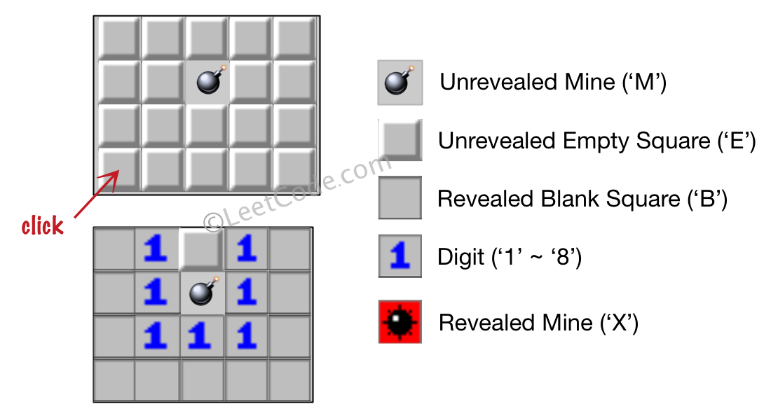

**Example 2:**

**Input:**

[['B', '1', 'E', '1', 'B'],

['B', '1', 'M', '1', 'B'],

['B', '1', '1', '1', 'B'],

['B', 'B', 'B', 'B', 'B']]

Click : [1,2]

**Output:**

[['B', '1', 'E', '1', 'B'],

['B', '1', 'X', '1', 'B'],

['B', '1', '1', '1', 'B'],

['B', 'B', 'B', 'B', 'B']]

**Explanation:**

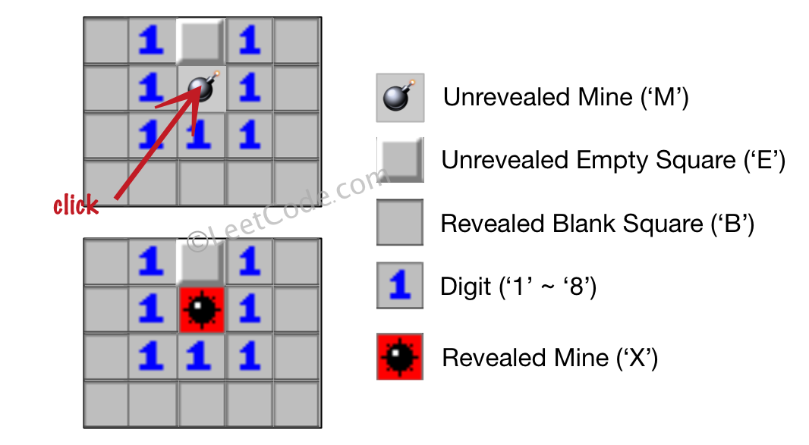

**Note:**

1. The range of the input matrix's height and width is [1,50].
2. The click position will only be an unrevealed square ('M' or 'E'), which also means the input board contains at least one clickable square.
3. The input board won't be a stage when game is over (some mines have been revealed).
4. For simplicity, not mentioned rules should be ignored in this problem. For example, you **don't** need to reveal all the unrevealed mines when the game is over, consider any cases that you will win the game or flag any squares.

class Solution {

public:

vector<vector<char>> updateBoard(vector<vector<char>>& board, vector<int>& click) {

n = board.size(), m = board[0].size();

if (board[click[0]][click[1]] == 'M') {

board[click[0]][click[1]] = 'X';

}

else dfs(click[0], click[1], board);

return board;

}

private:

int n, m;

const vector<int> dx{0,0,-1,1,-1,1,-1,1};

const vector<int> dy{-1,1,0,0,-1,1,1,-1};

void dfs(int x, int y, vector<vector<char>>& board) {

char cnt = '0';

vector<pair<int, int>> book;

for (int i = 0; i < 8; ++i) {

int xx = x + dx[i], yy = y + dy[i];

if (xx >= n || yy >= m || xx < 0 || yy < 0) continue;

if (board[xx][yy] == 'M') ++cnt;

if (board[xx][yy] == 'E')

book.push\_back({xx, yy});

}

board[x][y] = cnt == '0' ? 'B' : cnt;

if (cnt == '0') {

for (auto &pii : book) dfs(pii.first, pii.second, board);

}

}

};

### 530. Minimum Absolute Difference in BST

Easy

Given a binary search tree with non-negative values, find the minimum [absolute difference](https://en.wikipedia.org/wiki/Absolute_difference) between values of any two nodes.

**Example:**

**Input:**

1

\

3

/

2

**Output:**

1

**Explanation:**

The minimum absolute difference is 1, which is the difference between 2 and 1 (or between 2 and 3).

**Note:** There are at least two nodes in this BST.

/\*\*

\* Definition for a binary tree node.

\* struct TreeNode {

\* int val;

\* TreeNode \*left;

\* TreeNode \*right;

\* TreeNode(int x) : val(x), left(NULL), right(NULL) {}

\* };

\*/

class Solution **{**

public**:**

int getMinimumDifference**(**TreeNode**\*** p**)** **{**

int pre**,** res **=** INT\_MAX**;**

bool isFirst **=** **true;**

stack**<**TreeNode**\*>** stk**;**

**while** **(**p **||** **!**stk**.**empty**())** **{**

**while** **(**p**)** **{**

stk**.**push**(**p**);**

p **=** p**->**left**;**

**}**

p **=** stk**.**top**();**

stk**.**pop**();**

**if** **(**isFirst**)** **{**

pre **=** p**->**val**;**

isFirst **=** **false;**

**}**

**else** **{**

res **=** min**(**res**,** p**->**val **-** pre**);**

pre **=** p**->**val**;**

**}**

p **=** p**->**right**;**

**}**

**return** res**;**

**}**

**};**

### [531. Lonely Pixel I](https://leetcode-cn.com/problems/lonely-pixel-i/)

Given a picture consisting of black and white pixels, find the number of **black** lonely pixels.

The picture is represented by a 2D char array consisting of 'B' and 'W', which means black and white pixels respectively.

A black lonely pixel is character 'B' that located at a specific position where the same row and same column don't have any other black pixels.

**Example:**

**Input:**

[['W', 'W', 'B'],

['W', 'B', 'W'],

['B', 'W', 'W']]

**Output:** 3

**Explanation:** All the three 'B's are black lonely pixels.

**Note:**

1. The range of width and height of the input 2D array is [1,500].

class Solution {

public:

    int findLonelyPixel(vector<vector<char>>& picture) {

        int n = picture.size(), m = picture[0].size();

        vector<int> a(n), b(m);

        for (int i = 0; i < n; ++i) {

            for (int j = 0; j < m; ++j) {

                if (picture[i][j] == 'B') {

                    ++a[i], ++b[j];

                }

            }

        }

        int res = 0;

        for (int i = 0; i < n; ++i) {

            if (a[i] != 1) continue;

            for (int j = 0; j < m; ++j) {

                if (picture[i][j] == 'B' && b[j] == 1) ++res;

            }

        }

        return res;

    }

};

### 532. K-diff Pairs in an Array

Easy

Given an array of integers and an integer **k**, you need to find the number of **unique** k-diff pairs in the array. Here a **k-diff** pair is defined as an integer pair (i, j), where **i** and **j** are both numbers in the array and their [absolute difference](https://en.wikipedia.org/wiki/Absolute_difference) is **k**.

**Example 1:**

**Input:** [3, 1, 4, 1, 5], k = 2

**Output:** 2

**Explanation:** There are two 2-diff pairs in the array, (1, 3) and (3, 5).  
Although we have two 1s in the input, we should only return the number of **unique** pairs.

**Example 2:**

**Input:**[1, 2, 3, 4, 5], k = 1

**Output:** 4

**Explanation:** There are four 1-diff pairs in the array, (1, 2), (2, 3), (3, 4) and (4, 5).

**Example 3:**

**Input:** [1, 3, 1, 5, 4], k = 0

**Output:** 1

**Explanation:** There is one 0-diff pair in the array, (1, 1).

**Note:**

1. The pairs (i, j) and (j, i) count as the same pair.
2. The length of the array won't exceed 10,000.
3. All the integers in the given input belong to the range: [-1e7, 1e7].

class Solution **{**

public**:**

int findPairs**(**vector**<**int**>&** nums**,** int k**)** **{**

**if** **(**k **<** 0**)** **return** 0**;**

unordered\_map**<**int**,** int**>** mp**;**

**for** **(**auto **&**i **:** nums**)** **++**mp**[**i**];**

int res **=** 0**;**

**for** **(**auto **&**i **:** mp**)** **{**

**if** **(!**k **&&** i**.**second **>** 1 **||** k **&&** mp**.**count**(**i**.**first**+**k**))**

**++**res**;**

**}**

**return** res**;**

**}**

**};**

### [533. Lonely Pixel II](https://leetcode-cn.com/problems/lonely-pixel-ii/)

Given a picture consisting of black and white pixels, and a positive integer N, find the number of black pixels located at some specific row **R** and column **C** that align with all the following rules:

1. Row R and column C both contain exactly N black pixels.
2. For all rows that have a black pixel at column C, they should be exactly the same as row R

The picture is represented by a 2D char array consisting of 'B' and 'W', which means black and white pixels respectively.

**Example:**

**Input:**

[['W', 'B', 'W', 'B', 'B', 'W'],

['W', 'B', 'W', 'B', 'B', 'W'],

['W', 'B', 'W', 'B', 'B', 'W'],

['W', 'W', 'B', 'W', 'B', 'W']]

N = 3

**Output:** 6

**Explanation:** All the bold 'B' are the black pixels we need (all 'B's at column 1 and 3).

0 1 2 3 4 5 column index

0 [['W', **'B'**, 'W', **'B'**, 'B', 'W'],

1 ['W', **'B'**, 'W', **'B'**, 'B', 'W'],

2 ['W', **'B'**, 'W', **'B'**, 'B', 'W'],

3 ['W', 'W', 'B', 'W', 'B', 'W']]

row index

Take 'B' at row R = 0 and column C = 1 as an example:

Rule 1, row R = 0 and column C = 1 both have exactly N = 3 black pixels.

Rule 2, the rows have black pixel at column C = 1 are row 0, row 1 and row 2. They are exactly the same as row R = 0.

**Note:**

1. The range of width and height of the input 2D array is [1,200].

class Solution {

public:

    int findBlackPixel(vector<vector<char>>& picture, int N) {

        int n = picture.size(), m = picture[0].size();

        unordered\_map<string, int> mp;

        vector<int> b(m);

        for (int i = 0; i < n; ++i) {

            string s;

            int cnt = 0;

            for (int j = 0; j < m; ++j) {

                s += picture[i][j];

                if (picture[i][j] == 'B') {

                    ++b[j], ++cnt;

                }

            }

            if (cnt == N) ++mp[s];

        }

        int res = 0;

        for (auto &psi : mp) {

            if (psi.second == N) {

                for (int j = 0; j < m; ++j) {

                    if (psi.first[j] == 'B' && b[j] == N)

                        res += N;

                }

            }

        }

        return res;

    }

};

### [534. Game Play Analysis III](https://leetcode-cn.com/problems/game-play-analysis-iii/)（SQL）

SQL架构

Table: Activity

+--------------+---------+

| Column Name | Type |

+--------------+---------+

| player\_id | int |

| device\_id | int |

| event\_date | date |

| games\_played | int |

+--------------+---------+

(player\_id, event\_date) is the primary key of this table.

This table shows the activity of players of some game.

Each row is a record of a player who logged in and played a number of games (possibly 0) before logging out on some day using some device.

Write an SQL query that reports for each player and date, how many games played **so far** by the player. That is, the total number of games played by the player until that date. Check the example for clarity.

The query result format is in the following example:

Activity table:

+-----------+-----------+------------+--------------+

| player\_id | device\_id | event\_date | games\_played |

+-----------+-----------+------------+--------------+

| 1 | 2 | 2016-03-01 | 5 |

| 1 | 2 | 2016-05-02 | 6 |

| 1 | 3 | 2017-06-25 | 1 |

| 3 | 1 | 2016-03-02 | 0 |

| 3 | 4 | 2018-07-03 | 5 |

+-----------+-----------+------------+--------------+

Result table:

+-----------+------------+---------------------+

| player\_id | event\_date | games\_played\_so\_far |

+-----------+------------+---------------------+

| 1 | 2016-03-01 | 5 |

| 1 | 2016-05-02 | 11 |

| 1 | 2017-06-25 | 12 |

| 3 | 2016-03-02 | 0 |

| 3 | 2018-07-03 | 5 |

+-----------+------------+---------------------+

For the player with id 1, 5 + 6 = 11 games played by 2016-05-02, and 5 + 6 + 1 = 12 games played by 2017-06-25.

For the player with id 3, 0 + 5 = 5 games played by 2018-07-03.

Note that for each player we only care about the days when the player logged in.

select a.player\_id, a.event\_date,  sum(b.games\_played) as 'games\_played\_so\_far'

from Activity a

join Activity b on a.player\_id = b.player\_id and a.event\_date

>= b.event\_date

group by a.player\_id, a.event\_date;

select player\_id, event\_date,

sum(games\_played) over(partition by player\_id order by event\_date)

as 'games\_played\_so\_far'

from  activity;

### 535. Encode and Decode TinyURL

Medium

Note: This is a companion problem to the [System Design](https://leetcode.com/discuss/interview-question/system-design/) problem: [Design TinyURL](https://leetcode.com/discuss/interview-question/124658/Design-a-URL-Shortener-(-TinyURL-)-System/).

TinyURL is a URL shortening service where you enter a URL such as https://leetcode.com/problems/design-tinyurl and it returns a short URL such as http://tinyurl.com/4e9iAk.

Design the encode and decode methods for the TinyURL service. There is no restriction on how your encode/decode algorithm should work. You just need to ensure that a URL can be encoded to a tiny URL and the tiny URL can be decoded to the original URL.

class Solution {

public:

// Encodes a URL to a shortened URL.

string encode(string longUrl) {

string sid = ToBase62(id++);

urls[sid] = longUrl;

return sid;

}

// Decodes a shortened URL to its original URL.

string decode(string shortUrl) {

return urls[shortUrl];

}

private:

const string base62c = "0123456789abcdefghijklmnopqrstuvwxyzABCDEFGHIJKLMNOPQRSTUVWXYZ"s;

int id = 0;

unordered\_map<string, string> urls;

string ToBase62(int base10) {

string base62;

while (base10) {

base62 += base62c[base10 % 62];

base10 /= 62;

}

reverse(base62.begin(), base62.end());

return base62;

}

};

class Solution {

public:

// Encodes a URL to a shortened URL.

string encode(string longUrl) {

if (url2code.count(longUrl)) return url2code[longUrl];

string code;

do {

for (int i = 0; i < 6; ++i) code += base62c[rand() % 62];

} while(code2url.count(code));

code2url[code] = longUrl;

url2code[longUrl] = code;

return code;

}

// Decodes a shortened URL to its original URL.

string decode(string shortUrl) {

return code2url[shortUrl];

}

private:

const string base62c = "abcdefghijklmnopqrstuvwxyzABCDEFGHIJKLMNOPQRSTUVWXYZ0123456789"s;

unordered\_map<string, string> url2code, code2url;

};

### [536. Construct Binary Tree from String](https://leetcode-cn.com/problems/construct-binary-tree-from-string/)

You need to construct a binary tree from a string consisting of parenthesis and integers.

The whole input represents a binary tree. It contains an integer followed by zero, one or two pairs of parenthesis. The integer represents the root's value and a pair of parenthesis contains a child binary tree with the same structure.

You always start to construct the **left** child node of the parent first if it exists.

**Example 1:**

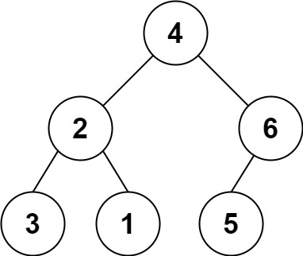

**Input:** s = "4(2(3)(1))(6(5))"

**Output:** [4,2,6,3,1,5]

**Example 2:**

**Input:** s = "4(2(3)(1))(6(5)(7))"

**Output:** [4,2,6,3,1,5,7]

**Example 3:**

**Input:** s = "-4(2(3)(1))(6(5)(7))"

**Output:** [-4,2,6,3,1,5,7]

**Constraints:**

* 0 <= s.length <= 3 \* 104
* s consists of digits, '(', ')', and '-' only.

/\*\*

 \* Definition for a binary tree node.

 \* struct TreeNode {

 \*     int val;

 \*     TreeNode \*left;

 \*     TreeNode \*right;

 \*     TreeNode() : val(0), left(nullptr), right(nullptr) {}

 \*     TreeNode(int x) : val(x), left(nullptr), right(nullptr) {}

 \*     TreeNode(int x, TreeNode \*left, TreeNode \*right) : val(x), left(left), right(right) {}

 \* };

 \*/

class Solution {

public:

    TreeNode\* str2tree(string s) {

        if (s.empty()) return nullptr;

        stringstream ss(s);

        return dfs(ss);

    }

    TreeNode \*dfs(stringstream &ss) {

        char c;

        int num = 0;

        int isneg = 1;

        if (ss.peek() == '-') {

            ss >> c;

            isneg = -1;

        }

        while (ss >> c && isdigit(c))  num = num\*10 + c-'0';

        auto p = new TreeNode(isneg \* num);

        if (c == '(') {

            p->left = dfs(ss);

            if (ss.peek() == '(') {

                ss >> c;

                p->right = dfs(ss);

            }

            ss >> c;

        }

        return p;

    }

};

### 537. Complex Number Multiplication

Medium

Given two strings representing two [complex numbers](https://en.wikipedia.org/wiki/Complex_number).

You need to return a string representing their multiplication. Note i2 = -1 according to the definition.

**Example 1:**

**Input:** "1+1i", "1+1i"

**Output:** "0+2i"

**Explanation:** (1 + i) \* (1 + i) = 1 + i2 + 2 \* i = 2i, and you need convert it to the form of 0+2i.

**Example 2:**

**Input:** "1+-1i", "1+-1i"

**Output:** "0+-2i"

**Explanation:** (1 - i) \* (1 - i) = 1 + i2 - 2 \* i = -2i, and you need convert it to the form of 0+-2i.

**Note:**

1. The input strings will not have extra blank.
2. The input strings will be given in the form of **a+bi**, where the integer **a** and **b** will both belong to the range of [-100, 100]. And **the output should be also in this form**.

class Solution {

public:

    string complexNumberMultiply(string a, string b) {

       smatch ma, mb;

       regex pattern(R"((-?\d+)\+(-?\d+)i)");

       regex\_match(a, ma, pattern);

       regex\_match(b, mb, pattern);

       int r1 = stoi(ma[1]), i1 = stoi(ma[2]),

r2 = stoi(mb[1]), i2 = stoi(mb[2]);

       return to\_string(r1 \* r2 - i1 \* i2) + '+'

+ to\_string(r1 \* i2 + r2 \* i1) + 'i';

    }

};

### 538. Convert BST to Greater Tree

Easy

Given a Binary Search Tree (BST), convert it to a Greater Tree such that every key of the original BST is changed to the original key plus sum of all keys greater than the original key in BST.

**Example:**

**Input:** The root of a Binary Search Tree like this:

5

/ \

2 13

**Output:** The root of a Greater Tree like this:

18

/ \

20 13

/\*\*

\* Definition for a binary tree node.

\* struct TreeNode {

\* int val;

\* TreeNode \*left;

\* TreeNode \*right;

\* TreeNode(int x) : val(x), left(NULL), right(NULL) {}

\* };

\*/

class Solution **{**

public**:**

TreeNode**\*** convertBST**(**TreeNode**\*** root**)** **{**

**if** **(!**root**)** **return** **nullptr;**

stack**<**TreeNode**\*>** stk**;**

TreeNode **\***p **=** root**;**

int sum **=** 0**;**

**while** **(!**stk**.**empty**()** **||** p**)** **{**

**while** **(**p**)** **{**

stk**.**push**(**p**);**

p **=** p**->**right**;**

**}**

p **=** stk**.**top**();**

stk**.**pop**();**

// visit

sum **=** p**->**val **=** p**->**val **+** sum**;**

p **=** p**->**left**;**

**}**

**return** root**;**

**}**

**};**

### 539. Minimum Time Difference

Medium

Given a list of 24-hour clock time points in "Hour:Minutes" format, find the minimum **minutes** difference between any two time points in the list.

**Example 1:**

**Input:** ["23:59","00:00"]

**Output:** 1

**Note:**

1. The number of time points in the given list is at least 2 and won't exceed 20000.
2. The input time is legal and ranges from 00:00 to 23:59.

class Solution **{**

public**:**

int findMinDifference**(**vector**<**string**>&** timePoints**)** **{**

vector**<**bool**>** bucket**(**24**\***60**,** **false);**

**for** **(**auto **&**s **:** timePoints**)** **{**

int time **=** stoi**(**s**.**substr**(**0**,** 2**))\***60 **+** stoi**(**s**.**substr**(**3**,** 2**));**

**if** **(**bucket**[**time**])** **return** 0**;**

bucket**[**time**]** **=** **true;**

**}**

int pre **=** **-**1**,** first**,** res **=** INT\_MAX**;**

**for** **(**int i **=** 0**;** i **<** 24**\***60**;** i**++)** **if** **(**bucket**[**i**])** **{**

**if** **(**pre **==** **-**1**)** first **=** pre **=** i**;**

**else** **{**

res **=** min**(**res**,** i**-**pre**);**

pre **=** i**;**

**}**

**}**

**return** min**(**res**,** first**+**24**\***60**-**pre**);**

**}**

**};**

### 540. Single Element in a Sorted Array

Medium

You are given a sorted array consisting of only integers where every element appears exactly twice, except for one element which appears exactly once. Find this single element that appears only once.

**Example 1:**

**Input:** [1,1,2,3,3,4,4,8,8]

**Output:** 2

**Example 2:**

**Input:** [3,3,7,7,10,11,11]

**Output:** 10

**Note:** Your solution should run in O(log n) time and O(1) space.

class Solution **{**

public**:**

int singleNonDuplicate**(**vector**<**int**>&** nums**)** **{**

int left **=** 0**,** right **=** nums**.**size**();**

**while** **(**left **+**1 **<** right**)** **{**

int mid **=** left **+** **(**right**-**left**)/**2**;**

**if** **(**mid **%** 2**)** **{**

**if** **(**nums**[**mid**]** **!=** nums**[**mid**-**1**])** right **=** mid**;**

**else** left **=** mid **+** 1**;**

**}**

**else** **{**

**if** **(**nums**[**mid**]** **!=** nums**[**mid**-**1**])** left **=** mid**;**

**else** right **=** mid **-** 1**;**

**}**

**}**

**return** nums**[**left**];**

**}**

**};**

### 541. Reverse String II

Easy

Given a string and an integer k, you need to reverse the first k characters for every 2k characters counting from the start of the string. If there are less than k characters left, reverse all of them. If there are less than 2k but greater than or equal to k characters, then reverse the first k characters and left the other as original.

**Example:**

**Input:** s = "abcdefg", k = 2

**Output:** "bacdfeg"

**Restrictions:**

1. The string consists of lower English letters only.
2. Length of the given string and k will in the range [1, 10000]

class Solution **{**

public**:**

string reverseStr**(**string s**,** int k**)** **{**

auto l **=** s**.**begin**();**

**while** **(**l **!=** s**.**end**())** **{**

auto r **=** **(**s**.**end**()** **-** l **>** k**)** **?** l **+** k **:** s**.**end**();**

reverse**(**l**,** r**);**

l **=** **(**s**.**end**()** **-** r **>** k**)** **?** r **+** k **:** s**.**end**();**

**}**

**return** s**;**

**}**

**};**

### 542. 01 Matrix

Medium

Given a matrix consists of 0 and 1, find the distance of the nearest 0 for each cell.

The distance between two adjacent cells is 1.

**Example 1:**

**Input:**

[[0,0,0],

[0,1,0],

[0,0,0]]

**Output:**

[[0,0,0],

 [0,1,0],

 [0,0,0]]

**Example 2:**

**Input:**

[[0,0,0],

[0,1,0],

[1,1,1]]

**Output:**

[[0,0,0],

[0,1,0],

[1,2,1]]

**Note:**

1. The number of elements of the given matrix will not exceed 10,000.
2. There are at least one 0 in the given matrix.
3. The cells are adjacent in only four directions: up, down, left and right.

class Solution **{**

public**:**

vector**<**vector**<**int**>>** updateMatrix**(**vector**<**vector**<**int**>>&** matrix**)** **{**

int n **=** matrix**.**size**(),** m **=** matrix**[**0**].**size**();**

const int MAX **=** 10000**+**10**;**

vector**<**vector**<**int**>>** res**(**n**,** vector**<**int**>(**m**,** MAX**));**

**for** **(**int i **=** 0**;** i **<** n**;** i**++)** **{**

**for** **(**int j **=** 0**;** j **<** m**;** j**++)** **{**

**if** **(!**matrix**[**i**][**j**])** res**[**i**][**j**]** **=** 0**;**

**else** **{**

int up **=** i **?** res**[**i**-**1**][**j**]** **:** MAX**;**

int left **=** j **?** res**[**i**][**j**-**1**]** **:** MAX**;**

res**[**i**][**j**]** **=** min**(**up**,** left**)+**1**;**

**}**

**}**

**}**

**for** **(**int i **=** n**-**1**;** i **>=** 0**;** i**--)** **{**

**for** **(**int j **=** m**-**1**;** j **>=** 0**;** j**--)** **if** **(**matrix**[**i**][**j**])** **{**

int down **=** i **!=** n**-**1 **?** res**[**i**+**1**][**j**]** **:** MAX**;**

int right **=** j **!=** m**-**1 **?** res**[**i**][**j**+**1**]** **:** MAX**;**

res**[**i**][**j**]** **=** min**(**res**[**i**][**j**],** min**(**down**,** right**)+**1**);**

**}**

**}**

**return** res**;**

**}**

**};**

### 543. Diameter of Binary Tree

Easy

Given a binary tree, you need to compute the length of the diameter of the tree. The diameter of a binary tree is the length of the **longest** path between any two nodes in a tree. This path may or may not pass through the root.

**Example:**  
Given a binary tree

1

/ \

2 3

/ \

4 5

Return **3**, which is the length of the path [4,2,1,3] or [5,2,1,3].

**Note:** The length of path between two nodes is represented by the number of edges between them.

/\*\*

\* Definition for a binary tree node.

\* struct TreeNode {

\* int val;

\* TreeNode \*left;

\* TreeNode \*right;

\* TreeNode(int x) : val(x), left(NULL), right(NULL) {}

\* };

\*/

class Solution **{**

public**:**

int diameterOfBinaryTree**(**TreeNode**\*** root**)** **{**

int res **=** 0**;**

f**(**root**,** res**);**

**return** res**;**

**}**

private**:**

int f**(**TreeNode **\***root**,** int **&**res**)** **{**

**if** **(!**root**)** **return** 0**;**

int L **=** f**(**root**->**left**,** res**);**

int R **=** f**(**root**->**right**,** res**);**

res **=** max**(**res**,** L**+**R**);**

**return** max**(**L**,** R**)** **+** 1**;**

**}**

**};**

### [544. Output Contest Matches](https://leetcode-cn.com/problems/output-contest-matches/)

During the NBA playoffs, we always arrange the rather strong team to play with the rather weak team, like make the rank 1 team play with the rank nth team, which is a good strategy to make the contest more interesting. Now, you're given **n** teams, you need to output their **final** contest matches in the form of a string.

The **n** teams are given in the form of positive integers from 1 to n, which represents their initial rank. (Rank 1 is the strongest team and Rank n is the weakest team.) We'll use parentheses('(', ')') and commas(',') to represent the contest team pairing - parentheses('(' , ')') for pairing and commas(',') for partition. During the pairing process in each round, you always need to follow the strategy of making the rather strong one pair with the rather weak one.

**Example 1:**

**Input:** 2

**Output:** (1,2)

**Explanation:**

Initially, we have the team 1 and the team 2, placed like: 1,2.

Then we pair the team (1,2) together with '(', ')' and ',', which is the final answer.

**Example 2:**

**Input:** 4

**Output:** ((1,4),(2,3))

**Explanation:**

In the first round, we pair the team 1 and 4, the team 2 and 3 together, as we need to make the strong team and weak team together.

And we got (1,4),(2,3).

In the second round, the winners of (1,4) and (2,3) need to play again to generate the final winner, so you need to add the paratheses outside them.

And we got the final answer ((1,4),(2,3)).

**Example 3:**

**Input:** 8

**Output:** (((1,8),(4,5)),((2,7),(3,6)))

**Explanation:**

First round: (1,8),(2,7),(3,6),(4,5)

Second round: ((1,8),(4,5)),((2,7),(3,6))

Third round: (((1,8),(4,5)),((2,7),(3,6)))

Since the third round will generate the final winner, you need to output the answer (((1,8),(4,5)),((2,7),(3,6))).

**Note:**

1. The **n** is in range [2, 212].
2. We ensure that the input **n** can be converted into the form 2k, where k is a positive integer.

class Solution {

public:

    string findContestMatch(int n) {

        vector<int> v(n+1);

        v[1] = 1;

        return dfs(1, n, 3, v);

    }

    string dfs(int st, int ed, int sum, vector<int> &v) {

        int mid = st+(ed-st)/2;

        v[mid+1] = sum - v[st];

        if (ed == st+1) return "(" + to\_string(v[st]) + ","

  + to\_string(v[ed]) + ")";

        string res = "(";

        res += dfs(st, mid, sum\*2-1, v) + ",";

        res += dfs(mid+1, ed, sum\*2-1, v) + ")";

        return res;

    }

};

### [545. Boundary of Binary Tree](https://leetcode-cn.com/problems/boundary-of-binary-tree/)★★

Given a binary tree, return the values of its boundary in **anti-clockwise** direction starting from root. Boundary includes left boundary, leaves, and right boundary in order without duplicate **nodes**.  (The values of the nodes may still be duplicates.)

**Left boundary** is defined as the path from root to the **left-most** node. **Right boundary** is defined as the path from root to the **right-most** node. If the root doesn't have left subtree or right subtree, then the root itself is left boundary or right boundary. Note this definition only applies to the input binary tree, and not applies to any subtrees.

The **left-most** node is defined as a **leaf** node you could reach when you always firstly travel to the left subtree if exists. If not, travel to the right subtree. Repeat until you reach a leaf node.

The **right-most** node is also defined by the same way with left and right exchanged.

**Example 1**

**Input:**

1

\

2

/ \

3 4

**Ouput:**

[1, 3, 4, 2]

**Explanation:**

The root doesn't have left subtree, so the root itself is left boundary.

The leaves are node 3 and 4.

The right boundary are node 1,2,4. Note the anti-clockwise direction means you should output reversed right boundary.

So order them in anti-clockwise without duplicates and we have [1,3,4,2].

**Example 2**

**Input:**

\_\_\_\_1\_\_\_\_\_

/ \

2 3

/ \ /

4 5 6

/ \ / \

7 8 9 10

**Ouput:**

[1,2,4,7,8,9,10,6,3]

**Explanation:**

The left boundary are node 1,2,4. (4 is the left-most node according to definition)

The leaves are node 4,7,8,9,10.

The right boundary are node 1,3,6,10. (10 is the right-most node).

So order them in anti-clockwise without duplicate nodes we have [1,2,4,7,8,9,10,6,3].

class Solution {

public:

vector<int> res;

    vector<int> boundaryOfBinaryTree(TreeNode\* root) {

        dfs(root, true, true);

        return res;

    }

    void dfs(TreeNode \*p, bool leftBound, bool rightBound) {

        if (!p) return;

        if (leftBound) res.emplace\_back(p->val);

        else if (!p->left && !p->right) {

            res.emplace\_back(p->val);

            return;

        }

        dfs(p->left, leftBound, !leftBound&&rightBound&&!p->right);

        dfs(p->right, !rightBound&&leftBound&&!p->left, rightBound);

        if (!leftBound && rightBound) {

            res.emplace\_back(p->val);

        }

    }

};

### 546. Remove Boxes★★

Hard

Given several boxes with different colors represented by different positive numbers.   
You may experience several rounds to remove boxes until there is no box left. Each time you can choose some continuous boxes with the same color (composed of k boxes, k >= 1), remove them and get k\*k points.  
Find the maximum points you can get.

**Example 1:**  
Input:

[1, 3, 2, 2, 2, 3, 4, 3, 1]

Output:

23

Explanation:

[1, 3, 2, 2, 2, 3, 4, 3, 1]

----> [1, 3, 3, 4, 3, 1] (3\*3=9 points)

----> [1, 3, 3, 3, 1] (1\*1=1 points)

----> [1, 1] (3\*3=9 points)

----> [] (2\*2=4 points)

**Note:** The number of boxes n would not exceed 100.

class Solution {

public:

    int removeBoxes(vector<int>& boxes) {

        return dfs(boxes, 0, boxes.size()-1, 0);

    }

private:

    int dp[100][100][100];

    int dfs(vector<int>& boxes, int l, int r, int k) {

        if (l > r) return 0;

        if (dp[l][r][k]) return dp[l][r][k];

        while (r > l && boxes[r] == boxes[r-1]) {r--;k++;}

        dp[l][r][k] = dfs(boxes, l, r-1, 0) + (k+1)\*(k+1);

        for (int i = l; i < r; ++i){

            if (boxes[i] == boxes[r]){

                dp[l][r][k] = max(dp[l][r][k], dfs(boxes, l, i, k+1)

+ dfs(boxes, i+1, r-1, 0));

            }

        }

        return dp[l][r][k];

    }

};

### 547. Friend Circles

Medium

There are **N** students in a class. Some of them are friends, while some are not. Their friendship is transitive in nature. For example, if A is a **direct** friend of B, and B is a **direct** friend of C, then A is an **indirect** friend of C. And we defined a friend circle is a group of students who are direct or indirect friends.

Given a **N\*N** matrix **M** representing the friend relationship between students in the class. If M[i][j] = 1, then the ith and jth students are **direct** friends with each other, otherwise not. And you have to output the total number of friend circles among all the students.

**Example 1:**

**Input:**

[[1,1,0],

[1,1,0],

[0,0,1]]

**Output:** 2

**Explanation:**The 0th and 1st students are direct friends, so they are in a friend circle.   
The 2nd student himself is in a friend circle. So return 2.

**Example 2:**

**Input:**

[[1,1,0],

[1,1,1],

[0,1,1]]

**Output:** 1

**Explanation:**The 0th and 1st students are direct friends, the 1st and 2nd students are direct friends,   
so the 0th and 2nd students are indirect friends. All of them are in the same friend circle, so return 1.

**Note:**

1. N is in range [1,200].
2. M[i][i] = 1 for all students.
3. If M[i][j] = 1, then M[j][i] = 1.

class Solution **{**

public**:**

int findCircleNum**(**vector**<**vector**<**int**>>&** M**)** **{**

int n **=** M**.**size**(),** res **=** n**;**

vector**<**int**>** fa**(**n**);**

**for** **(**int i **=** 0**;** i **<** n**;** i**++)** fa**[**i**]** **=** i**;**

**for** **(**int i **=** 0**;** i **<** n**;** i**++)** **{**

**for** **(**int j **=** 0**;** j **<** i**;** j**++)** **if** **(**M**[**i**][**j**])** **{**

int fa0 **=** find**(**fa**,** i**);**

int fa1 **=** find**(**fa**,** j**);**

**if** **(**fa0 **!=** fa1**)** **{**

fa**[**fa0**]** **=** fa1**;**

res**--;**

**}**

**}**

**}**

**return** res**;**

**}**

private**:**

int find**(**vector**<**int**>** **&**fa**,** int x**)** **{**

**return** x **==** fa**[**x**]** **?** x **:** **(**fa**[**x**]** **=** find**(**fa**,** fa**[**x**]));**

**}**

**};**

### [548. Split Array with Equal Sum](https://leetcode-cn.com/problems/split-array-with-equal-sum/)★

Given an array with n integers, you need to find if there are triplets (i, j, k) which satisfies following conditions:

1. 0 < i, i + 1 < j, j + 1 < k < n - 1
2. Sum of subarrays (0, i - 1), (i + 1, j - 1), (j + 1, k - 1) and (k + 1, n - 1) should be equal.

where we define that subarray (L, R) represents a slice of the original array starting from the element indexed L to the element indexed R.

**Example:**

**Input:** [1,2,1,2,1,2,1]

**Output:** True

**Explanation:**

i = 1, j = 3, k = 5.

sum(0, i - 1) = sum(0, 0) = 1

sum(i + 1, j - 1) = sum(2, 2) = 1

sum(j + 1, k - 1) = sum(4, 4) = 1

sum(k + 1, n - 1) = sum(6, 6) = 1

**Note:**

1. 1 <= n <= 2000.
2. Elements in the given array will be in range [-1,000,000, 1,000,000].

class Solution {

public:

    bool splitArray(vector<int>& nums) {

        int n = nums.size();

        if (n < 7) return false;

        vector<int> preS;

        partial\_sum(nums.begin(), nums.end(), back\_inserter(preS));

        for (int j = 3; j < n - 3; ++j) {

            unordered\_set<int> st;

            for (int i = 1; i < j-1; ++i) {

                int sum1 = preS[i-1];

                int sum2 = preS[j-1] - preS[i];

                if (sum1 == sum2) st.insert(sum1);

            }

            for (int k = j+2; k < n-1; ++k) {

                int sum3 = preS[k-1] - preS[j];

                int sum4 = preS[n-1] - preS[k];

                if (sum3 == sum4 && st.count(sum3)) return true;

            }

        }

        return false;

    }

};

### [549. Binary Tree Longest Consecutive Sequence II](https://leetcode-cn.com/problems/binary-tree-longest-consecutive-sequence-ii/)

Given a binary tree, you need to find the length of Longest Consecutive Path in Binary Tree.

Especially, this path can be either increasing or decreasing. For example, [1,2,3,4] and [4,3,2,1] are both considered valid, but the path [1,2,4,3] is not valid. On the other hand, the path can be in the child-Parent-child order, where not necessarily be parent-child order.

**Example 1:**

**Input:**

1

/ \

2 3

**Output:** 2

**Explanation:** The longest consecutive path is [1, 2] or [2, 1].

**Example 2:**

**Input:**

2

/ \

1 3

**Output:** 3

**Explanation:** The longest consecutive path is [1, 2, 3] or [3, 2, 1].

**Note:** All the values of tree nodes are in the range of [-1e7, 1e7].

/\*\*

 \* Definition for a binary tree node.

 \* struct TreeNode {

 \*     int val;

 \*     TreeNode \*left;

 \*     TreeNode \*right;

 \*     TreeNode(int x) : val(x), left(NULL), right(NULL) {}

 \* };

 \*/

class Solution {

public:

    int longestConsecutive(TreeNode\* root) {

        dfs(root);

        return res;

    }

private:

    int res = 0;

    pair<int, int> dfs(TreeNode \*root) {  //{+, -}

        if (!root) return {0, 0};

        pair<int, int> ret = {1, 1};

        auto l = dfs(root->left), r = dfs(root->right);

        if (root->left && root->left->val == root->val+1)

            ret.first = max(ret.first, l.first+1);

        else l.first = 0;

        if (root->left && root->left->val == root->val-1)

            ret.second = max(ret.second, l.second+1);

        else l.second = 0;

        if (root->right && root->right->val == root->val+1)

            ret.first = max(ret.first, r.first+1);

        else r.first = 0;

        if (root->right && root->right->val == root->val-1)

            ret.second = max(ret.second, r.second+1);

        else r.second = 0;

        res = max(res,  1+max(l.first+r.second, l.second+r.first));

        return ret;

    }

};

### [550. Game Play Analysis IV](https://leetcode-cn.com/problems/game-play-analysis-iv/)（SQL）

SQL架构

Table: Activity

+--------------+---------+

| Column Name | Type |

+--------------+---------+

| player\_id | int |

| device\_id | int |

| event\_date | date |

| games\_played | int |

+--------------+---------+

(player\_id, event\_date) is the primary key of this table.

This table shows the activity of players of some game.

Each row is a record of a player who logged in and played a number of games (possibly 0) before logging out on some day using some device.

Write an SQL query that reports the **fraction** of players that logged in again on the day after the day they first logged in, **rounded to 2 decimal places**. In other words, you need to count the number of players that logged in for at least two consecutive days starting from their first login date, then divide that number by the total number of players.

The query result format is in the following example:

Activity table:

+-----------+-----------+------------+--------------+

| player\_id | device\_id | event\_date | games\_played |

+-----------+-----------+------------+--------------+

| 1 | 2 | 2016-03-01 | 5 |

| 1 | 2 | 2016-03-02 | 6 |

| 2 | 3 | 2017-06-25 | 1 |

| 3 | 1 | 2016-03-02 | 0 |

| 3 | 4 | 2018-07-03 | 5 |

+-----------+-----------+------------+--------------+

Result table:

+-----------+

| fraction |

+-----------+

| 0.33 |

+-----------+

Only the player with id 1 logged back in after the first day he had logged in so the answer is 1/3 = 0.33

select

    ROUND((select count(\*)

        from Activity

        where (player\_id, event\_date) in

(select player\_id, Date(min(event\_date)+1)

               from Activity

               group by player\_id)

    ) / count(distinct player\_id), 2) as fraction

from Activity;

### 551. Student Attendance Record I

Easy

You are given a string representing an attendance record for a student. The record only contains the following three characters:

1. **'A'** : Absent.
2. **'L'** : Late.
3. **'P'** : Present.

A student could be rewarded if his attendance record doesn't contain **more than one 'A' (absent)** or **more than two continuous 'L' (late)**.

You need to return whether the student could be rewarded according to his attendance record.

**Example 1:**

**Input:** "PPALLP"

**Output:** True

**Example 2:**

**Input:** "PPALLL"

**Output:** False

class Solution **{**

public**:**

bool checkRecord**(**string s**)** **{**

int L **=** 0**,** A **=** 0**,** L\_cnt **=** 0**;**

**for** **(**auto **&**c **:** s**)** **{**

**switch(**c**)** **{**

**case** 'A'**:** A**++;** L\_cnt **=** 0**;** **break;**

**case** 'L'**:** L **=** max**(**L**,** **++**L\_cnt**);** **break;**

**case** 'P'**:** L\_cnt **=** 0**;** **break;**

**}**

**}**

**return** L **<** 3 **&&** A **<** 2**;**

**}**

**};**

### 552. Student Attendance Record II

Hard

Given a positive integer **n**, return the number of all possible attendance records with length n, which will be regarded as rewardable. The answer may be very large, return it after mod 109 + 7.

A student attendance record is a string that only contains the following three characters:

1. **'A'** : Absent.
2. **'L'** : Late.
3. **'P'** : Present.

A record is regarded as rewardable if it doesn't contain **more than one 'A' (absent)** or **more than two continuous 'L' (late)**.

**Example 1:**

**Input:** n = 2

**Output:** 8

**Explanation:**

There are 8 records with length 2 will be regarded as rewardable:

"PP" , "AP", "PA", "LP", "PL", "AL", "LA", "LL"

Only "AA" won't be regarded as rewardable owing to more than one absent times.

**Note:** The value of **n** won't exceed 100,000.

class Solution {

public:

    int checkRecord(int n) {

        if (n <= 0) return 0;

        vector<vector<long long>> v(2, vector<long long>(6, 0));

        const long long Mod = 1e9+7;

        v[0][0] = 1;

        int k = 0;

        while (n--) {

            auto &pre = v[k], &cur = v[k^1];

            cur[0] = (pre[0] + pre[1] + pre[2]) % Mod;

            cur[1] = pre[0];

            cur[2] = pre[1];

            cur[3] = (cur[0] + pre[3] + pre[4] + pre[5]) % Mod;

            cur[4] = pre[3];

            cur[5] = pre[4];

            k ^= 1;

        }

       Return (accumulate(v[k].begin(), v[k].end(), (long long)0))%Mod;

    }

};

### 553. Optimal Division

Medium

Given a list of **positive integers**, the adjacent integers will perform the float division. For example, [2,3,4] -> 2 / 3 / 4.

However, you can add any number of parenthesis at any position to change the priority of operations. You should find out how to add parenthesis to get the **maximum** result, and return the corresponding expression in string format. **Your expression should NOT contain redundant parenthesis.**

**Example:**

**Input:** [1000,100,10,2]

**Output:** "1000/(100/10/2)"

**Explanation:**

1000/(100/10/2) = 1000/((100/10)/2) = 200

However, the bold parenthesis in "1000/(**(**100/10**)**/2)" are redundant,   
since they don't influence the operation priority. So you should return "1000/(100/10/2)".

Other cases:

1000/(100/10)/2 = 50

1000/(100/(10/2)) = 50

1000/100/10/2 = 0.5

1000/100/(10/2) = 2

**Note:**

1. The length of the input array is [1, 10].
2. Elements in the given array will be in range [2, 1000].
3. There is only one optimal division for each test case.

class Solution {

public:

string optimalDivision(vector<int>& nums) {

string res;

if (nums.empty()) return res;

res = to\_string(nums[0]);

if (nums.size() == 1) return res;

if (nums.size() == 2) return res + "/" + to\_string(nums[1]);

res += "/(" + to\_string(nums[1]);

for (int i = 2; i < nums.size();++i)

res += "/" + to\_string(nums[i]);

return res + ")";

}

};

### 554. Brick Wall

Medium

There is a brick wall in front of you. The wall is rectangular and has several rows of bricks. The bricks have the same height but different width. You want to draw a vertical line from the **top** to the **bottom** and cross the **least** bricks.

The brick wall is represented by a list of rows. Each row is a list of integers representing the width of each brick in this row from left to right.

If your line go through the edge of a brick, then the brick is not considered as crossed. You need to find out how to draw the line to cross the least bricks and return the number of crossed bricks.

**You cannot draw a line just along one of the two vertical edges of the wall, in which case the line will obviously cross no bricks.**

**Example:**

**Input:** [[1,2,2,1],

[3,1,2],

[1,3,2],

[2,4],

[3,1,2],

[1,3,1,1]]

**Output:** 2

**Explanation:**

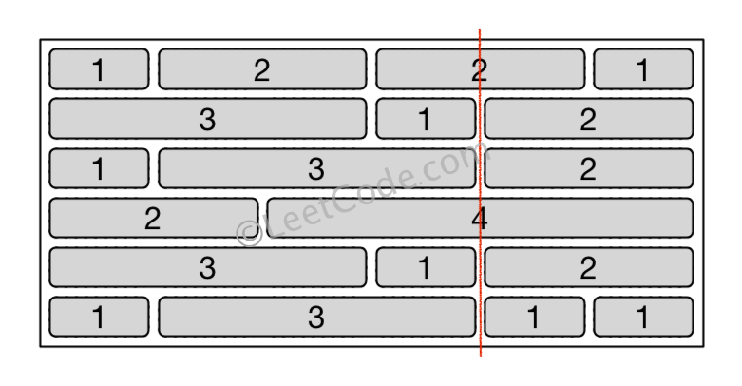

**Note:**

1. The width sum of bricks in different rows are the same and won't exceed INT\_MAX.
2. The number of bricks in each row is in range [1,10,000]. The height of wall is in range [1,10,000]. Total number of bricks of the wall won't exceed 20,000.

class Solution **{**

public**:**

int leastBricks**(**vector**<**vector**<**int**>>** **&**wall**)** **{**

unordered\_map**<**int**,** int**>** m**;**

int res **=** 0**,** sz **=** wall**.**size**();**

**for** **(**int i **=** 0**;** i **<** sz**;** i**++)** **{**

**for** **(**int j **=** 0**,** sum **=** 0**;** j **<** wall**[**i**].**size**()** **-** 1**;** j**++)** **{**

res **=** max**(**res**,** **++**m**[**sum **+=** wall**[**i**][**j**]]);**

**}**

**}**

**return** sz **-** res**;**

**}**

**};**

### [555. Split Concatenated Strings](https://leetcode-cn.com/problems/split-concatenated-strings/) ★★

Given a list of strings, you could concatenate these strings together into a loop, where for each string you could choose to reverse it or not. Among all the possible loops, you need to find the lexicographically biggest string after cutting the loop, which will make the looped string into a regular one.

Specifically, to find the lexicographically biggest string, you need to experience two phases:

1. Concatenate all the strings into a loop, where you can reverse some strings or not and connect them in the same order as given.
2. Cut and make one breakpoint in any place of the loop, which will make the looped string into a regular one starting from the character at the cutpoint.

And your job is to find the lexicographically biggest one among all the possible regular strings.

**Example:**

**Input:** "abc", "xyz"

**Output:** "zyxcba"

**Explanation:** You can get the looped string "-abcxyz-", "-abczyx-", "-cbaxyz-", "-cbazyx-",   
where '-' represents the looped status.   
The answer string came from the fourth looped one,   
where you could cut from the middle character 'a' and get "zyxcba".

**Note:**

1. The input strings will only contain lowercase letters.
2. The total length of all the strings will not over 1,000.

class Solution {

public:

string splitLoopedString(vector<string>& strs) {

string s, res = "a";

for (const &str : strs) {

string r = str;

reverse(r.begin(), r.end());

s += max(str, r);

}

for (int i = 0, st = 0; i < strs.size(); st += strs[i++].size()) {

string p1 = strs[i], p2 = strs[i];

reverse(p2.begin(), p2.end());

string body = s.substr(st + p2.size()) + s.substr(0, st);

for (auto j = 0; j < strs[i].size(); ++j) {

if (p1[j] >= res[0]) {

res = max(res, p1.substr(j) + body + p1.substr(0, j));

}

if (p2[j] >= res[0]) {

res = max(res, p2.substr(j) + body + p2.substr(0, j));

}

}

}

return res;

}

}

### 556. Next Greater Element III

Medium

Given a positive **32-bit** integer **n**, you need to find the smallest **32-bit** integer which has exactly the same digits existing in the integer **n** and is greater in value than n. If no such positive **32-bit** integer exists, you need to return -1.

**Example 1:**

**Input:** 12

**Output:** 21

**Example 2:**

**Input:** 21

**Output:** -1

class Solution **{**

public**:**

int nextGreaterElement**(**int n**)** **{**

string s **=** to\_string**(**n**);**

**if** **(!**next\_permutation**(**s**.**begin**(),** s**.**end**()))** **return** **-**1**;**

long long res **=** stoll**(**s**);**

**return** res **>** INT\_MAX **?** **-**1 **:** res**;**

**}**

**};**

### 557. Reverse Words in a String III

Given a string, you need to reverse the order of characters in each word within a sentence while still preserving whitespace and initial word order.

Example 1:

Input: "Let's take LeetCode contest"

Output: "s'teL ekat edoCteeL tsetnoc"

Note:

In the string, each word is separated by single space and there will not be any extra space in the string.

class Solution {

public:

string reverseWords(string s) {

string::iterator p = s.begin(), q;

while (p != s.end()) {

q = p;

while (q != s.end() && \*q != ' ') q++;

reverse(p, q);

if (q == s.end()) break;

p = ++q;

}

return s;

}

};

### 558. Quad Tree Intersection

Easy

A quadtree is a tree data in which each internal node has exactly four children: topLeft, topRight, bottomLeft and bottomRight. Quad trees are often used to partition a two-dimensional space by recursively subdividing it into four quadrants or regions.

We want to store True/False information in our quad tree. The quad tree is used to represent a N \* N boolean grid. For each node, it will be subdivided into four children nodes **until the values in the region it represents are all the same**. Each node has another two boolean attributes : isLeaf and val. isLeaf is true if and only if the node is a leaf node. The val attribute for a leaf node contains the value of the region it represents.

For example, below are two quad trees A and B:

A:

+---------+----------+ T: true

| | | F: false

| T | T |

| | |

+-------+-----------+

| | |

| F | F |

| | |

+-------+-----------+

topLeft: T

topRight: T

bottomLeft: F

bottomRight: F

B:

+---------+----+----+

| | F | F |

| T +-----+---+

| | T | T |

+--------+-----+-----+

| | |

| T | F |

| | |

+---------+--------+

topLeft: T

topRight:

topLeft: F

topRight: F

bottomLeft: T

bottomRight: T

bottomLeft: T

bottomRight: F

Your task is to implement a function that will take two quadtrees and return a quadtree that represents the logical OR (or union) of the two trees.

A: B: C (A or B):

+-------+-------+ +-------+---+---+ +-------+-------+

| | | | | F | F | | | |

| T | T | | T +---+---+ | T | T |

| | | | | T | T | | | |

+-------+-------+ +-------+---+---+ +-------+-------+

| | | | | | | | |

| F | F | | T | F | | T | F |

| | | | | | | | |

+-------+-------+ +-------+-------+ +-------+-------+

**Note:**

1. Both A and B represent grids of size N \* N.
2. N is guaranteed to be a power of 2.
3. If you want to know more about the quad tree, you can refer to its [wiki](https://en.wikipedia.org/wiki/Quadtree).
4. The logic OR operation is defined as this: "A or B" is true if A is true, or if B is true, or if both A and B are true.

/\*

// Definition for a QuadTree node.

class Node {

public:

bool val;

bool isLeaf;

Node\* topLeft;

Node\* topRight;

Node\* bottomLeft;

Node\* bottomRight;

Node() {}

Node(bool \_val, bool \_isLeaf, Node\* \_topLeft, Node\* \_topRight, Node\* \_bottomLeft, Node\* \_bottomRight) {

val = \_val;

isLeaf = \_isLeaf;

topLeft = \_topLeft;

topRight = \_topRight;

bottomLeft = \_bottomLeft;

bottomRight = \_bottomRight;

}

};

\*/

class Solution **{**

public**:**

Node**\*** intersect**(**Node**\*** T1**,** Node**\*** T2**)** **{**

Node **\***T **=** **new** Node**(false,** **false,** **nullptr,** **nullptr,** **nullptr,** **nullptr);**

**if** **(**T1**->**isLeaf **&&** T2**->**isLeaf**)** **{**

T**->**isLeaf **=** **true;**

T**->**val **=** **(**T1**->**val **||** T2**->**val**);**

**}**

**else** **if** **(**T1**->**isLeaf **||** T2**->**isLeaf**)** **{**

**if** **(!**T1**->**isLeaf**)** swap**(**T1**,** T2**);**

**if** **(**T1**->**val**)** T**->**isLeaf **=** T**->**val **=** **true;**

**else** T **=** T2**;**

**}**

**else** **{**

T**->**topLeft **=** intersect**(**T1**->**topLeft**,** T2**->**topLeft**);**

T**->**topRight **=** intersect**(**T1**->**topRight**,** T2**->**topRight**);**

T**->**bottomLeft **=** intersect**(**T1**->**bottomLeft**,** T2**->**bottomLeft**);**

T**->**bottomRight **=**intersect**(**T1**->**bottomRight**,**T2**->**bottomRight**);**

**}**

**if** **(!**T**->**isLeaf **&&** T**->**topLeft**->**val **&&** T**->**topRight**->**val

**&&** T**->**bottomLeft**->**val **&&** T**->**bottomRight**->**val**)** **{**

T**->**isLeaf **=** T**->**val **=** **true;**

**}**

**return** T**;**

**}**

**};**

### 559. Maximum Depth of N-ary Tree

Easy

Given a n-ary tree, find its maximum depth.

The maximum depth is the number of nodes along the longest path from the root node down to the farthest leaf node.

*Nary-Tree input serialization is represented in their level order traversal, each group of children is separated by the null value (See examples).*

**Example 1:**

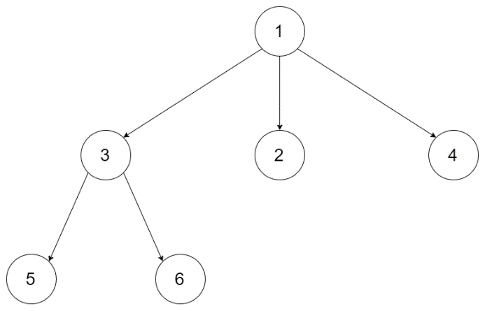

**Input:** root = [1,null,3,2,4,null,5,6]

**Output:** 3

**Example 2:**

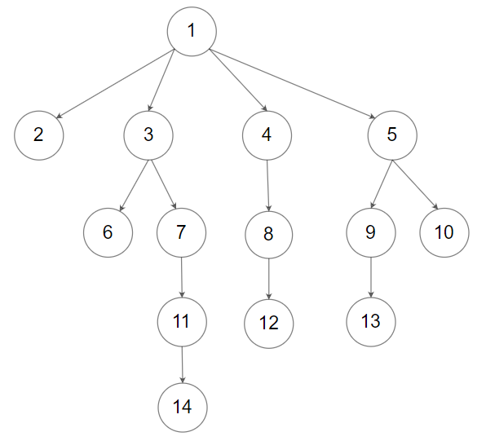

**Input:** root = [1,null,2,3,4,5,null,null,6,7,null,8,null,9,10,null,null,11,null,12,null,13,null,null,14]

**Output:** 5

**Constraints:**

* The depth of the n-ary tree is less than or equal to 1000.
* The total number of nodes is between [0, 10^4].

/\*

// Definition for a Node.

class Node {

public:

int val;

vector<Node\*> children;

Node() {}

Node(int \_val, vector<Node\*> \_children) {

val = \_val;

children = \_children;

}

};

\*/

class Solution **{**

public**:**

int maxDepth**(**Node**\*** root**)** **{**

**if** **(!**root**)** **return** 0**;**

int depth **=** 0**;**

**for** **(**auto child **:** root**->**children**)**

depth **=** max**(**depth**,** maxDepth**(**child**));**

**return** 1 **+** depth**;**

**}**

**};**

### 560. Subarray Sum Equals K

Medium

Given an array of integers and an integer **k**, you need to find the total number of continuous subarrays whose sum equals to **k**.

**Example 1:**

**Input:**nums = [1,1,1], k = 2

**Output:** 2

**Note:**

1. The length of the array is in range [1, 20,000].
2. The range of numbers in the array is [-1000, 1000] and the range of the integer **k** is [-1e7, 1e7].

class Solution {

public:

int subarraySum(vector<int>& nums, int k) {

unordered\_map<int, int> mp{{0, 1}};

int sum = 0, res = 0, sz = nums.size();

for (int i = 0; i < sz; i++) {

sum += nums[i];

res += (mp.count(sum-k) ? mp[sum-k] : 0);

++mp[sum];

}

return res;

}

};

### 561. Array Partition I

Easy

Given an array of **2n** integers, your task is to group these integers into **n** pairs of integer, say (a1, b1), (a2, b2), ..., (an, bn) which makes sum of min(ai, bi) for all i from 1 to n as large as possible.

**Example 1:**

**Input:** [1,4,3,2]

**Output:** 4

**Explanation:** n is 2, and the maximum sum of pairs is 4 = min(1, 2) + min(3, 4).

**Note:**

1. **n** is a positive integer, which is in the range of [1, 10000].
2. All the integers in the array will be in the range of [-10000, 10000].

class Solution {

public:

int arrayPairSum(vector<int>& nums) {

sort(nums.begin(), nums.end());

int res = 0;

for (int i = 0; i < nums.size(); i += 2) res += nums[i];

return res;

}

};

### [562. Longest Line of Consecutive One in Matrix](https://leetcode-cn.com/problems/longest-line-of-consecutive-one-in-matrix/)

Given a 01 matrix **M**, find the longest line of consecutive one in the matrix. The line could be horizontal, vertical, diagonal or anti-diagonal.

**Example:**

**Input:**

[[0,1,1,0],

[0,1,1,0],

[0,0,0,1]]

**Output:** 3

**Hint:** The number of elements in the given matrix will not exceed 10,000.

class Solution {

public:

    int longestLine(vector<vector<int>>& M) {

        if (M.empty()) return 0;

        int n = M.size(), m = M[0].size(), res = 0;

        vector<int> v(m, 0), a(m, 0), b(m, 0);

        for (int i = 0; i < n; ++i) {

            int h = 0;

            vector<int> d = a, anti\_d= b;

            for (int j = 0; j < m; ++j) {

                if (!M[i][j]) h = v[j] = a[j] = b[j] = 0;

                else {

                    if (j != 0) a[j] = d[j-1] + 1;

                    if (j != m-1) b[j] = anti\_d[j+1] + 1;

                    res = max({res, ++h, ++v[j], a[j], b[j]});

                }

            }

        }

        return res;

    }

};

### 563. Binary Tree Tilt

Easy

Given a binary tree, return the tilt of the **whole tree**.

The tilt of a **tree node** is defined as the **absolute difference** between the sum of all left subtree node values and the sum of all right subtree node values. Null node has tilt 0.

The tilt of the **whole tree** is defined as the sum of all nodes' tilt.

**Example:**

**Input:**

1

/ \

2 3

**Output:** 1

**Explanation:**

Tilt of node 2 : 0

Tilt of node 3 : 0

Tilt of node 1 : |2-3| = 1

Tilt of binary tree : 0 + 0 + 1 = 1

**Note:**

1. The sum of node values in any subtree won't exceed the range of 32-bit integer.
2. All the tilt values won't exceed the range of 32-bit integer.

/\*\*

\* Definition for a binary tree node.

\* struct TreeNode {

\* int val;

\* TreeNode \*left;

\* TreeNode \*right;

\* TreeNode(int x) : val(x), left(NULL), right(NULL) {}

\* };

\*/

class Solution **{**

public**:**

int findTilt**(**TreeNode**\*** root**)** **{**

int res **=** 0**;**

dfs**(**root**,** res**);**

**return** res**;**

**}**

private**:**

int dfs**(**TreeNode **\***root**,** int **&**res**)** **{**

**if** **(!**root**)** **return** 0**;**

int left **=** dfs**(**root**->**left**,** res**);**

int right **=** dfs**(**root**->**right**,** res**);**

res **+=** abs**(**left**-**right**);**

**return** left **+** right **+** root**->**val**;**

**}**

**};**

### 564. Find the Closest Palindrome★★

Hard

Given an integer n, find the closest integer (not including itself), which is a palindrome.

The 'closest' is defined as absolute difference minimized between two integers.

**Example 1:**

**Input:** "123"

**Output:** "121"

**Note:**

1. The input **n** is a positive integer represented by string, whose length will not exceed 18.
2. If there is a tie, return the smaller one as answer.

class Solution {

public:

/\*\*

\* 讨论结果的可能性: 对于数字s, 离它最近的回文数字只可能是以下5个中的一个,

\* - (long long)pow(10, n) + 1, /// 10...01 or 11

\* - (long long)pow(10, n - 1) - 1, // 9...9 or 0

\* - 前半部分-1 + 前半部分-1翻转

\* - 前半部分 + 前半部分翻转

\* - 前半部分+1 + 前半部分+1翻转

\* 注意: 对于后3种情况, 当长度n为奇数时, 翻转时不要中间位

\*/

using ll = long long;

string nearestPalindromic(string s) {

int n = s.length();

// 前两种情况

vector<ll> candidates = {

(ll) pow(10, n) + 1, // 10...01 or 11

(ll) pow(10, n - 1) - 1, // 9...9 or 0

};

// 后三种情况

ll prefix = stol(s.substr(0, (n + 1) / 2));

for (int i : {-1, 0, 1}) {

string p = to\_string(prefix + i);

string pp = p + string(p.rbegin() + (n & 1), p.rend());

candidates.push\_back(stoll(pp));

}

// 找出与slef差距最小且本身最小且不是self的值

ll self = stoll(s);

auto cmp = [&self](auto e1, auto e2) -> bool {

if (e1 == self) return false;

if (e2 == self) return true;

if (abs(self - e1) == abs(self - e2)) return e1 < e2;

return abs(self - e1) < abs(self - e2);

};

return to\_string(\*min\_element(candidates.begin(), candidates.end(), cmp));

}

};

### 565. Array Nesting

Medium

A zero-indexed array A of length N contains all integers from 0 to N-1. Find and return the longest length of set S, where S[i] = {A[i], A[A[i]], A[A[A[i]]], ... } subjected to the rule below.

Suppose the first element in S starts with the selection of element A[i] of index = i, the next element in S should be A[A[i]], and then A[A[A[i]]]… By that analogy, we stop adding right before a duplicate element occurs in S.

**Example 1:**

**Input:** A = [5,4,0,3,1,6,2]

**Output:** 4

**Explanation:**

A[0] = 5, A[1] = 4, A[2] = 0, A[3] = 3, A[4] = 1, A[5] = 6, A[6] = 2.

One of the longest S[K]:

S[0] = {A[0], A[5], A[6], A[2]} = {5, 6, 2, 0}

**Note:**

1. N is an integer within the range [1, 20,000].
2. The elements of A are all distinct.
3. Each element of A is an integer within the range [0, N-1].

class Solution **{**

public**:**

int arrayNesting**(**vector**<**int**>&** nums**)** **{**

int n **=** nums**.**size**(),** cnt **=** 0**,** res **=** 0**;**

**for** **(**int i **=** 0**;** i **<** n**;** **++**i**)** **if** **(**nums**[**i**]** **>=** 0**)** **{**

int j **=** i**;**

**while** **(**nums**[**j**]** **>=** 0**)** **{**

int t **=** nums**[**j**];**

nums**[**j**]** **=** **-**1**;**

j **=** t**;**

cnt**++;**

**}**

res **=** max**(**res**,** cnt**);**

cnt **=** 0**;**

**}**

**return** res**;**

**}**

**};**

### 566. Reshape the Matrix

Easy

In MATLAB, there is a very useful function called 'reshape', which can reshape a matrix into a new one with different size but keep its original data.

You're given a matrix represented by a two-dimensional array, and two **positive** integers **r** and **c** representing the **row** number and **column** number of the wanted reshaped matrix, respectively.

The reshaped matrix need to be filled with all the elements of the original matrix in the same **row-traversing** order as they were.

If the 'reshape' operation with given parameters is possible and legal, output the new reshaped matrix; Otherwise, output the original matrix.

**Example 1:**

**Input:**

nums =

[[1,2],

[3,4]]

r = 1, c = 4

**Output:**

[[1,2,3,4]]

**Explanation:**  
The **row-traversing** of nums is [1,2,3,4]. The new reshaped matrix is a 1 \* 4 matrix, fill it row by row by using the previous list.

**Example 2:**

**Input:**

nums =

[[1,2],

[3,4]]

r = 2, c = 4

**Output:**

[[1,2],

[3,4]]

**Explanation:**  
There is no way to reshape a 2 \* 2 matrix to a 2 \* 4 matrix. So output the original matrix.

**Note:**

1. The height and width of the given matrix is in range [1, 100].
2. The given r and c are all positive.

class Solution **{**

public**:**

vector**<**vector**<**int**>>** matrixReshape**(**vector**<**vector**<**int**>>&** nums**,** int r**,** int c**)** **{**

int n **=** nums**.**size**(),** m **=** nums**[**0**].**size**();**

**if** **(**n**\***m **!=** r**\***c**)** **return** nums**;**

vector**<**vector**<**int**>>** res**;**

vector**<**int**>** temp**;**

int cnt **=** 0**;**

**for** **(**auto **&**v **:** nums**)** **{**

**for** **(**auto **&**i **:** v**)** **{**

temp**.**push\_back**(**i**);**

**if** **(++**cnt **%** c **==** 0**)** **{**

res**.**push\_back**(**temp**);**

temp**.**clear**();**

**}**

**}**

**}**

**return** res**;**

**}**

**};**

### 567. Permutation in String

Medium

Given two strings **s1** and **s2**, write a function to return true if **s2** contains the permutation of **s1**. In other words, one of the first string's permutations is the **substring** of the second string.

**Example 1:**

**Input:** s1 = "ab" s2 = "eidbaooo"

**Output:** True

**Explanation:** s2 contains one permutation of s1 ("ba").

**Example 2:**

**Input:**s1= "ab" s2 = "eidboaoo"

**Output:** False

**Note:**

1. The input strings only contain lower case letters.
2. The length of both given strings is in range [1, 10,000].

class Solution **{**

public**:**

bool checkInclusion**(**string s1**,** string s2**)** **{**

unordered\_map**<**char**,** int**>** m1**,** m2**;**

**for(**auto **&**c **:** s1**)** m1**[**c**]++;**

int cnt **=** 0**,** left **=** 0**;**

int len1 **=** s1**.**length**(),** len2 **=** s2**.**length**();**

**for(**int i **=** 0**;** i **<** len2**;** i**++)** **{**

char c **=** s2**[**i**];**

**if** **(**m1**.**count**(**c**))** **{**

**if** **(++**m2**[**c**]** **>** m1**[**c**])** **{**

**while** **(**s2**[**left**]** **!=** c**)** **{**

m2**[**s2**[**left**++]]--;**

cnt**--;**

**}**

m2**[**s2**[**left**++]]--;**

**}**

**else** **if** **(++**cnt **==** len1**)** **return** **true;**

**}**

**else** **{**

left **=** i**+**1**;**

cnt **=** 0**;**

m2**.**clear**();**

**}**

**}**

**return** **false;**

**}**

**};**

### [568. Maximum Vacation Days](https://leetcode-cn.com/problems/maximum-vacation-days/)

LeetCode wants to give one of its best employees the option to travel among **N** cities to collect algorithm problems. But all work and no play makes Jack a dull boy, you could take vacations in some particular cities and weeks. Your job is to schedule the traveling to maximize the number of vacation days you could take, but there are certain rules and restrictions you need to follow.

**Rules and restrictions:**

1. You can only travel among **N** cities, represented by indexes from 0 to N-1. Initially, you are in the city indexed 0 on **Monday**.
2. The cities are connected by flights. The flights are represented as a **N\*N** matrix (not necessary symmetrical), called **flights** representing the airline status from the city i to the city j. If there is no flight from the city i to the city j, **flights[i][j] = 0**; Otherwise, **flights[i][j] = 1**. Also, **flights[i][i] = 0** for all i.
3. You totally have **K** weeks (**each week has 7 days**) to travel. You can only take flights at most once **per day** and can only take flights on each week's **Monday** morning. Since flight time is so short, we don't consider the impact of flight time.
4. For each city, you can only have restricted vacation days in different weeks, given an **N\*K** matrix called **days** representing this relationship. For the value of **days[i][j]**, it represents the maximum days you could take vacation in the city **i** in the week **j**.

You're given the **flights** matrix and **days** matrix, and you need to output the maximum vacation days you could take during **K** weeks.

**Example 1:**

**Input:**flights = [[0,1,1],[1,0,1],[1,1,0]], days = [[1,3,1],[6,0,3],[3,3,3]]

**Output:** 12

**Explanation:**   
Ans = 6 + 3 + 3 = 12.

One of the best strategies is:

1st week : fly from city 0 to city 1 on Monday, and play 6 days and work 1 day.   
(Although you start at city 0, we could also fly to and start at other cities since it is Monday.)

2nd week : fly from city 1 to city 2 on Monday, and play 3 days and work 4 days.

3rd week : stay at city 2, and play 3 days and work 4 days.

**Example 2:**

**Input:**flights = [[0,0,0],[0,0,0],[0,0,0]], days = [[1,1,1],[7,7,7],[7,7,7]]

**Output:** 3

**Explanation:**   
Ans = 1 + 1 + 1 = 3.

Since there is no flights enable you to move to another city, you have to stay at city 0 for the whole 3 weeks.   
For each week, you only have one day to play and six days to work.   
So the maximum number of vacation days is 3.

**Example 3:**

**Input:**flights = [[0,1,1],[1,0,1],[1,1,0]], days = [[7,0,0],[0,7,0],[0,0,7]]

**Output:** 21

**Explanation:**  
Ans = 7 + 7 + 7 = 21

One of the best strategies is:

1st week : stay at city 0, and play 7 days.

2nd week : fly from city 0 to city 1 on Monday, and play 7 days.

3rd week : fly from city 1 to city 2 on Monday, and play 7 days.

**Note:**

1. **N and K** are positive integers, which are in the range of [1, 100].
2. In the matrix **flights**, all the values are integers in the range of [0, 1].
3. In the matrix **days**, all the values are integers in the range [0, 7].
4. You could stay at a city beyond the number of vacation days, but you should **work** on the extra days, which won't be counted as vacation days.
5. If you fly from the city A to the city B and take the vacation on that day, the deduction towards vacation days will count towards the vacation days of city B in that week.
6. We don't consider the impact of flight hours towards the calculation of vacation days.

class Solution {

public:

int maxVacationDays(vector<vector<int>>& flights, vector<vector<int>>& days) {

int n = flights.size(), k = days[0].size();

vector<int> dp(n, INT\_MIN);

dp[0] = 0;

for (int j = 0; j < k; ++j) {

vector<int> t(n, INT\_MIN);

for (int i = 0; i < n; ++i) {

for (int p = 0; p < n; ++p) {

if (i == p || flights[p][i]) {

t[i] = max(t[i], dp[p] + days[i][j]);

}

}

}

dp = std::move(t);

}

return \*max\_element(dp.begin(), dp.end());

}

};

### [569. Median Employee Salary](https://leetcode-cn.com/problems/median-employee-salary/)（SQL）

SQL架构

The Employee table holds all employees. The employee table has three columns: Employee Id, Company Name, and Salary.

+-----+------------+--------+

|Id | Company | Salary |

+-----+------------+--------+

|1 | A | 2341 |

|2 | A | 341 |

|3 | A | 15 |

|4 | A | 15314 |

|5 | A | 451 |

|6 | A | 513 |

|7 | B | 15 |

|8 | B | 13 |

|9 | B | 1154 |

|10 | B | 1345 |

|11 | B | 1221 |

|12 | B | 234 |

|13 | C | 2345 |

|14 | C | 2645 |

|15 | C | 2645 |

|16 | C | 2652 |

|17 | C | 65 |

+-----+------------+--------+

Write a SQL query to find the median salary of each company. Bonus points if you can solve it without using any built-in SQL functions.

+-----+------------+--------+

|Id | Company | Salary |

+-----+------------+--------+

|5 | A | 451 |

|6 | A | 513 |

|12 | B | 234 |

|9 | B | 1154 |

|14 | C | 2645 |

+-----+------------+--------+

select Id, Company, Salary

from (

    select Id, Company, Salary,

        row\_number() over(partition by Company order by Salary) as rnk,

        count(\*) over(partition by Company) as cnt

    from Employee ) t

where rnk in (cnt/2, cnt/2+1, cnt/2+0.5)

### [570. Managers with at Least 5 Direct Reports](https://leetcode-cn.com/problems/managers-with-at-least-5-direct-reports/)（SQL）

SQL架构

The Employee table holds all employees including their managers. Every employee has an Id, and there is also a column for the manager Id.

+------+----------+-----------+----------+

|Id |Name |Department |ManagerId |

+------+----------+-----------+----------+

|101 |John |A |null |

|102 |Dan |A |101 |

|103 |James |A |101 |

|104 |Amy |A |101 |

|105 |Anne |A |101 |

|106 |Ron |B |101 |

+------+----------+-----------+----------+

Given the Employee table, write a SQL query that finds out managers with at least 5 direct report. For the above table, your SQL query should return:

+-------+

| Name |

+-------+

| John |

+-------+

**Note:**  
No one would report to himself.

select a.Name as 'Name'

from Employee a

join Employee b on b.ManagerId = a.Id

group by a.Id

having count(\*) > 4

### [571. Find Median Given Frequency of Numbers](https://leetcode-cn.com/problems/find-median-given-frequency-of-numbers/)(SQL)

SQL架构

The Numbers table keeps the value of number and its frequency.

+----------+-------------+

| Number | Frequency |

+----------+-------------|

| 0 | 7 |

| 1 | 1 |

| 2 | 3 |

| 3 | 1 |

+----------+-------------+

In this table, the numbers are 0, 0, 0, 0, 0, 0, 0, 1, 2, 2, 2, 3, so the median is (0 + 0) / 2 = 0.

+--------+

| median |

+--------|

| 0.0000 |

+--------+

Write a query to find the median of all numbers and name the result as median.

select avg(Number) as median from

(

    select Number, @c1 + 1 as 'c1', (@c1 := @c1 + Frequency) as 'c2', t2.s

    from Numbers

    join (select @c1 := 0) t1

    join (select sum(Frequency) as s from Numbers) t2

    order by Number

) tmp

where c1 <= s/2 + 1 and c2 >= s/2;

### 572. Subtree of Another Tree

Easy

Given two non-empty binary trees **s** and **t**, check whether tree **t** has exactly the same structure and node values with a subtree of **s**. A subtree of **s** is a tree consists of a node in **s** and all of this node's descendants. The tree **s** could also be considered as a subtree of itself.

**Example 1:**  
Given tree s:

3

/ \

4 5

/ \

1 2

Given tree t:

4

/ \

1 2

Return **true**, because t has the same structure and node values with a subtree of s.

**Example 2:**  
Given tree s:

3

/ \

4 5

/ \

1 2

/

0

Given tree t:

4

/ \

1 2

Return **false**.

/\*\*

\* Definition for a binary tree node.

\* struct TreeNode {

\* int val;

\* TreeNode \*left;

\* TreeNode \*right;

\* TreeNode(int x) : val(x), left(NULL), right(NULL) {}

\* };

\*/

class Solution {

public:

    bool isSubtree(TreeNode\* s, TreeNode\* t) {

        string strs = "#" + treeTostring(s) + "#";

        string strt = "#" + treeTostring(t) + "#";

        return strs.find(strt) != string::npos;

    }

private:

    string treeTostring(TreeNode \*t) {

        if (!t) return "Null";

        string l = treeTostring(t->left);

        string r = treeTostring(t->right);

        return to\_string(t->val) + "#" + l + "#" + r;

    }

};

class Solution **{**

public**:**

bool isSubtree**(**TreeNode**\*** s**,** TreeNode**\*** t**)** **{**

**if(!**s**)** **return** **false;**

**return** isSameTree**(**s**,**t**)** **||** isSubtree**(**s**->**left**,**t**)**

**||** isSubtree**(**s**->**right**,**t**);**

**}**

private**:**

bool isSameTree**(**TreeNode**\*** p**,** TreeNode**\*** q**)** **{**

**if** **(!**p **&&** **!**q**)** **return** **true;**

**else** **if** **(!**p **||** **!**q **||** p**->**val **!=** q**->**val**)** **return** **false;**

**else** **return** isSameTree**(**p**->**left**,** q**->**left**)**

**&&** isSameTree**(**p**->**right**,** q**->**right**);**

**}**

**};**

### [573. Squirrel Simulation](https://leetcode-cn.com/problems/squirrel-simulation/)

There's a tree, a squirrel, and several nuts. Positions are represented by the cells in a 2D grid. Your goal is to find the **minimal** distance for the squirrel to collect all the nuts and put them under the tree one by one. The squirrel can only take at most **one nut** at one time and can move in four directions - up, down, left and right, to the adjacent cell. The distance is represented by the number of moves.

**Example 1:**

**Input:**

Height : 5

Width : 7

Tree position : [2,2]

Squirrel : [4,4]

Nuts : [[3,0], [2,5]]

**Output:** 12

**Explanation:**

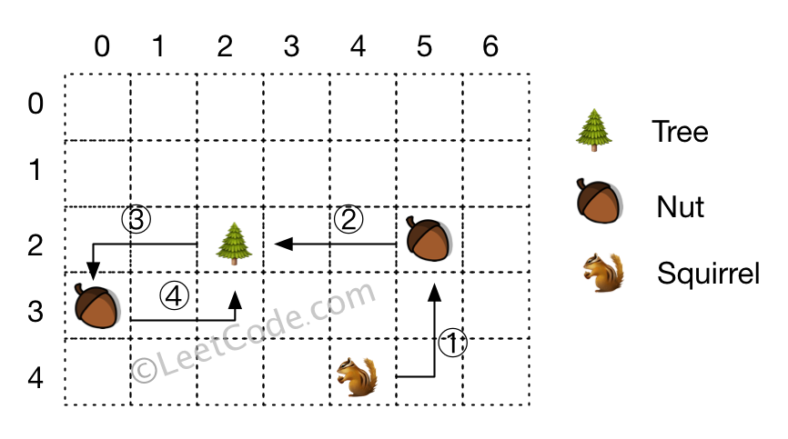​​​​​

**Note:**

1. All given positions won't overlap.
2. The squirrel can take at most one nut at one time.
3. The given positions of nuts have no order.
4. Height and width are positive integers. 3 <= height \* width <= 10,000.
5. The given positions contain at least one nut, only one tree and one squirrel.

class Solution {

public:

int minDistance(int height, int width, vector<int>& tree,

vector<int>& squirrel, vector<vector<int>>& nuts) {

        int sum = 0;

        int d = INT\_MAX;

        for (const auto &v : nuts) {

            int d0 = abs(v[0] - tree[0]) + abs(v[1] - tree[1]);

            int d1 = abs(v[0]-squirrel[0]) + abs(v[1]-squirrel[1]);

            sum += 2\*d0;

            d = min(d, d1-d0);

        }

        return sum + d;

    }

};

### [574. Winning Candidate](https://leetcode-cn.com/problems/winning-candidate/)(SQL)

SQL架构

Table: Candidate

+-----+---------+

| id | Name |

+-----+---------+

| 1 | A |

| 2 | B |

| 3 | C |

| 4 | D |

| 5 | E |

+-----+---------+

Table: Vote

+-----+--------------+

| id | CandidateId |

+-----+--------------+

| 1 | 2 |

| 2 | 4 |

| 3 | 3 |

| 4 | 2 |

| 5 | 5 |

+-----+--------------+

id is the auto-increment primary key,

CandidateId is the id appeared in Candidate table.

Write a sql to find the name of the winning candidate, the above example will return the winner B.

+------+

| Name |

+------+

| B |

+------+

**Notes:**

1. You may assume **there is no tie**, in other words there will be **only one** winning candidate.

select a.Name

from Candidate a

join Vote b on a.id = b.CandidateId

group by a.id

order by count(\*) desc

limit 0, 1

select Name

from Candidate

where id = (

                select CandidateId

                from Vote

                group by CandidateId

                order by count(\*) desc

                limit 1

            )

### 575. Distribute Candies

Easy

Given an integer array with **even** length, where different numbers in this array represent different **kinds** of candies. Each number means one candy of the corresponding kind. You need to distribute these candies **equally** in number to brother and sister. Return the maximum number of **kinds** of candies the sister could gain.

**Example 1:**

**Input:** candies = [1,1,2,2,3,3]

**Output:** 3

**Explanation:**

There are three different kinds of candies (1, 2 and 3), and two candies for each kind.

Optimal distribution: The sister has candies [1,2,3] and the brother has candies [1,2,3], too.

The sister has three different kinds of candies.

**Example 2:**

**Input:** candies = [1,1,2,3]

**Output:** 2

**Explanation:** For example, the sister has candies [2,3] and the brother has candies [1,1].

The sister has two different kinds of candies, the brother has only one kind of candies.

**Note:**

1. The length of the given array is in range [2, 10,000], and will be even.
2. The number in given array is in range [-100,000, 100,000].

class Solution **{**

public**:**

int distributeCandies**(**vector**<**int**>&** candies**)** **{**

unordered\_set**<**int**>** Myset**(**candies**.**begin**(),** candies**.**end**());**

**return** min**(**Myset**.**size**(),** candies**.**size**()/**2**);**

**}**

**};**

### 576. Out of Boundary Paths

Medium

There is an **m** by **n** grid with a ball. Given the start coordinate **(i,j)** of the ball, you can move the ball to **adjacent** cell or cross the grid boundary in four directions (up, down, left, right). However, you can **at most** move **N** times. Find out the number of paths to move the ball out of grid boundary. The answer may be very large, return it after mod 109 + 7.

**Example 1:**

**Input:** m = 2, n = 2, N = 2, i = 0, j = 0

**Output:** 6

**Explanation:**

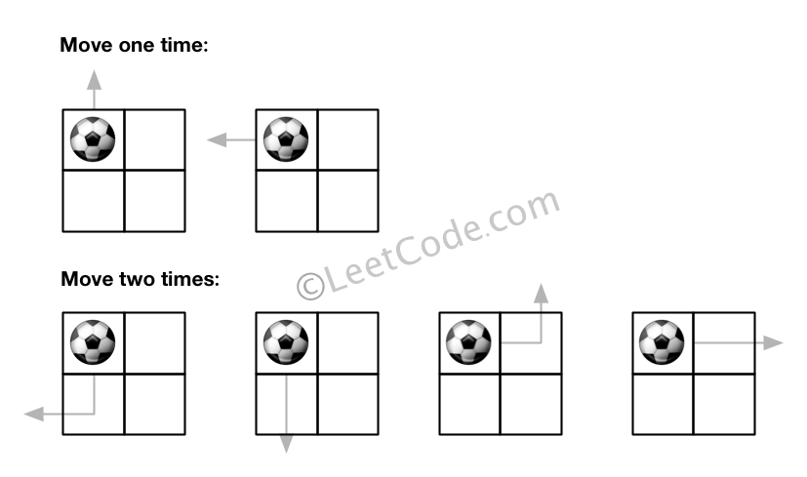

**Example 2:**

**Input:** m = 1, n = 3, N = 3, i = 0, j = 1

**Output:** 12

**Explanation:**

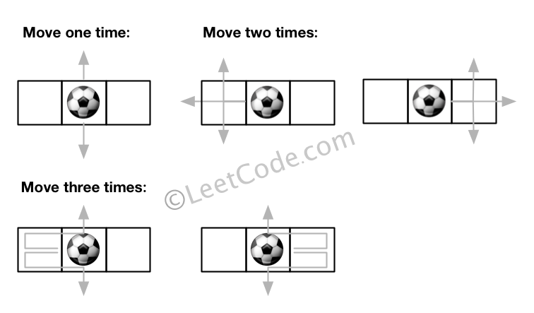

**Note:**

1. Once you move the ball out of boundary, you cannot move it back.
2. The length and height of the grid is in range [1,50].
3. N is in range [0,50].

class Solution **{**

public**:**

int findPaths**(**int m**,** int n**,** int N**,** int i**,** int j**)** **{**

**return** dfs**(**i**,** j**,** N**-**1**,** m**,** n**);**

**}**

private**:**

vector**<**int**>** dx**{-**1**,** 1**,** 0**,** 0**},** dy**{**0**,** 0**,** **-**1**,** 1**};**

const int MOD **=** 1000000007**;**

map**<**tuple**<**int**,** int**,** int**>,** long**>** mp**;**

int dfs**(**int x**,** int y**,** int z**,** int n**,** int m**)** **{**

**if** **(**z **<** 0**)** **return** 0**;**

auto t **=** make\_tuple**(**x**,** y**,** z**);**

**if** **(**mp**.**count**(**t**))** **return** mp**[**t**];**

long ret **=** 0**;**

**for** **(**int k **=** 0**;** k **<** 4**;** **++**k**)** **{**

int xx **=** x **+** dx**[**k**],** yy **=** y **+** dy**[**k**];**

**if** **(**xx **<** 0 **||** yy **<** 0 **||** xx **>=** n **||** yy **>=** m**)** ret**++;**

**else** ret **+=** dfs**(**xx**,** yy**,** z**-**1**,** n**,** m**);**

**}**

**return** mp**[**t**]** **=** **(**ret **%=** MOD**);**

**}**

**};**

### [577. Employee Bonus](https://leetcode-cn.com/problems/employee-bonus/)(SQL)

SQL架构

Select all employee's name and bonus whose bonus is < 1000.

Table:Employee

+-------+--------+-----------+--------+

| empId | name | supervisor| salary |

+-------+--------+-----------+--------+

| 1 | John | 3 | 1000 |

| 2 | Dan | 3 | 2000 |

| 3 | Brad | null | 4000 |

| 4 | Thomas | 3 | 4000 |

+-------+--------+-----------+--------+

empId is the primary key column for this table.

Table: Bonus

+-------+-------+

| empId | bonus |

+-------+-------+

| 2 | 500 |

| 4 | 2000 |

+-------+-------+

empId is the primary key column for this table.

Example ouput:

+-------+-------+

| name | bonus |

+-------+-------+

| John | null |

| Dan | 500 |

| Brad | null |

+-------+-------+

select name, bonus

from Employee a

left join bonus b on a.empId = b.empId

where ifnull(bonus, 0) < 1000;

### [578. Get Highest Answer Rate Question](https://leetcode-cn.com/problems/get-highest-answer-rate-question/)

SQL架构

Get the highest answer rate question from a table survey\_log with these columns: **id**, **action**, **question\_id**, **answer\_id**, **q\_num**, **timestamp**.

id means user id; action has these kind of values: "show", "answer", "skip"; answer\_id is not null when action column is "answer", while is null for "show" and "skip"; q\_num is the numeral order of the question in current session.

Write a sql query to identify the question which has the highest answer rate.

**Example:**

**Input:**

+------+-----------+--------------+------------+-----------+------------+

| id | action | question\_id | answer\_id | q\_num | timestamp |

+------+-----------+--------------+------------+-----------+------------+

| 5 | show | 285 | null | 1 | 123 |

| 5 | answer | 285 | 124124 | 1 | 124 |

| 5 | show | 369 | null | 2 | 125 |

| 5 | skip | 369 | null | 2 | 126 |

+------+-----------+--------------+------------+-----------+------------+

**Output:**

+-------------+

| survey\_log |

+-------------+

| 285 |

+-------------+

**Explanation:**

question 285 has answer rate 1/1, while question 369 has 0/1 answer rate, so output 285.

**Note:** The highest answer rate meaning is: answer number's ratio in show number in the same question.

#count 不计null行

select question\_id as 'survey\_log'

from survey\_log

where action <> 'skip'

group by question\_id

order by count(answer\_id) / (count(\*) - count(answer\_id)) desc

limit 1

#sum里面可以加函数

select question\_id as survey\_log

from survey\_log

group by question\_id

order by sum(if(action = 'answer', 1, 0)) / sum(if(action = 'show', 1, 0)) desc

limit 1

### [579. Find Cumulative Salary of an Employee](https://leetcode-cn.com/problems/find-cumulative-salary-of-an-employee/)

SQL架构

The **Employee** table holds the salary information in a year.

Write a SQL to get the cumulative sum of an employee's salary over a period of 3 months but exclude the most recent month.

The result should be displayed by 'Id' ascending, and then by 'Month' descending.

**Example**  
**Input**

| Id | Month | Salary |

|----|-------|--------|

| 1 | 1 | 20 |

| 2 | 1 | 20 |

| 1 | 2 | 30 |

| 2 | 2 | 30 |

| 3 | 2 | 40 |

| 1 | 3 | 40 |

| 3 | 3 | 60 |

| 1 | 4 | 60 |

| 3 | 4 | 70 |

**Output**

| Id | Month | Salary |

|----|-------|--------|

| 1 | 3 | 90 |

| 1 | 2 | 50 |

| 1 | 1 | 20 |

| 2 | 1 | 20 |

| 3 | 3 | 100 |

| 3 | 2 | 40 |

**Explanation**

Employee '1' has 3 salary records for the following 3 months except the most recent month '4': salary 40 for month '3', 30 for month '2' and 20 for month '1'  
So the cumulative sum of salary of this employee over 3 months is 90(40+30+20), 50(30+20) and 20 respectively.

| Id | Month | Salary |

|----|-------|--------|

| 1 | 3 | 90 |

| 1 | 2 | 50 |

| 1 | 1 | 20 |

Employee '2' only has one salary record (month '1') except its most recent month '2'.

| Id | Month | Salary |

|----|-------|--------|

| 2 | 1 | 20 |

Employ '3' has two salary records except its most recent pay month '4': month '3' with 60 and month '2' with 40. So the cumulative salary is as following.

| Id | Month | Salary |

|----|-------|--------|

| 3 | 3 | 100 |

| 3 | 2 | 40 |

select Id, Month, sum(Salary) over (partition by Id order by Month rows 2 preceding)  as Salary

from Employee

where (Id, Month) not in (

                            select Id, max(Month)

                            from Employee

                            group by Id

                         )

order by Id, Month desc

### [580. Count Student Number in Departments](https://leetcode-cn.com/problems/count-student-number-in-departments/)(SQL)

SQL架构

A university uses 2 data tables, ***student*** and ***department***, to store data about its students and the departments associated with each major.

Write a query to print the respective department name and number of students majoring in each department for all departments in the ***department*** table (even ones with no current students).

Sort your results by descending number of students; if two or more departments have the same number of students, then sort those departments alphabetically by department name.

The ***student*** is described as follow:

| Column Name | Type |

|--------------|-----------|

| student\_id | Integer |

| student\_name | String |

| gender | Character |

| dept\_id | Integer |

where student\_id is the student's ID number, student\_name is the student's name, gender is their gender, and dept\_id is the department ID associated with their declared major.

And the ***department*** table is described as below:

| Column Name | Type |

|-------------|---------|

| dept\_id | Integer |

| dept\_name | String |

where dept\_id is the department's ID number and dept\_name is the department name.

Here is an example **input**:  
***student*** table:

| student\_id | student\_name | gender | dept\_id |

|------------|--------------|--------|---------|

| 1 | Jack | M | 1 |

| 2 | Jane | F | 1 |

| 3 | Mark | M | 2 |

***department*** table:

| dept\_id | dept\_name |

|---------|-------------|

| 1 | Engineering |

| 2 | Science |

| 3 | Law |

The **Output** should be:

| dept\_name | student\_number |

|-------------|----------------|

| Engineering | 2 |

| Science | 1 |

| Law | 0 |

select dept\_name, count(student\_id) `student\_number`

from department a

left join student b on a.dept\_id = b.dept\_id

group by a.dept\_id

order by student\_number desc, dept\_name

### 581. Shortest Unsorted Continuous Subarray

Easy

Given an integer array, you need to find one **continuous subarray** that if you only sort this subarray in ascending order, then the whole array will be sorted in ascending order, too.

You need to find the **shortest** such subarray and output its length.

**Example 1:**

**Input:** [2, 6, 4, 8, 10, 9, 15]

**Output:** 5

**Explanation:** You need to sort [6, 4, 8, 10, 9] in ascending order to make the whole array sorted in ascending order.

**Note:**

1. Then length of the input array is in range [1, 10,000].
2. The input array may contain duplicates, so ascending order here means **<=**.

/\*\*

\* /------------\

\* nums: [2, 6, 4, 8, 10, 9, 15]

\* minr: 2 4 4 8 9 9 15

\* <--------------------

\* maxl: 2 6 6 8 10 10 15

\* -------------------->

\*/

class Solution {

public:

int findUnsortedSubarray(vector<int>& nums) {

int n = nums.size();

vector<int> maxlhs(n); // max number from left to cur

vector<int> minrhs(n); // min number from right to cur

for (int i = n-1, minr = INT\_MAX; i >= 0; --i)

minrhs[i] = minr = min(minr, nums[i]);

for (int i = 0, maxl = INT\_MIN; i < n; ++i)

maxlhs[i] = maxl = max(maxl, nums[i]);

int i = 0, j = n-1;

while (i < n && nums[i] == minrhs[i]) ++i;

while (j > i && nums[j] == maxlhs[j]) --j;

return j + 1 - i;

}

};

### [582. Kill Process](https://leetcode-cn.com/problems/kill-process/)

Given **n** processes, each process has a unique **PID (process id)** and its **PPID (parent process id)**.

Each process only has one parent process, but may have one or more children processes. This is just like a tree structure. Only one process has PPID that is 0, which means this process has no parent process. All the PIDs will be distinct positive integers.

We use two list of integers to represent a list of processes, where the first list contains PID for each process and the second list contains the corresponding PPID.

Now given the two lists, and a PID representing a process you want to kill, return a list of PIDs of processes that will be killed in the end. You should assume that when a process is killed, all its children processes will be killed. No order is required for the final answer.

**Example 1:**

**Input:**

pid = [1, 3, 10, 5]

ppid = [3, 0, 5, 3]

kill = 5

**Output:** [5,10]

**Explanation:**

3

/ \

1 5

/

10

Kill 5 will also kill 10.

**Note:**

1. The given kill id is guaranteed to be one of the given PIDs.
2. n >= 1.

class Solution {

public:

vector<int> killProcess(vector<int>& pid, vector<int>& ppid,

int kill) {

        vector<int> res;

        unordered\_map<int , vector<int>> mp;

        for (int i = 0; i < ppid.size(); ++i) {

            mp[ppid[i]].emplace\_back(pid[i]);

        }

        stack<int> stk;

        stk.push(kill);

        while (!stk.empty()) {

            int t = stk.top();

            stk.pop();

            res.emplace\_back(t);

            if (mp.count(t)) {

                for (auto i : mp[t])

                    stk.push(i);

            }

        }

        return res;

    }

};

### 583. Delete Operation for Two Strings

Medium

Given two words *word1* and *word2*, find the minimum number of steps required to make *word1* and *word2* the same, where in each step you can delete one character in either string.

**Example 1:**

**Input:** "sea", "eat"

**Output:** 2

**Explanation:** You need one step to make "sea" to "ea" and another step to make "eat" to "ea".

**Note:**

1. The length of given words won't exceed 500.
2. Characters in given words can only be lower-case letters.

class Solution **{**

public**:**

int minDistance**(**string s**,** string t**)** **{**

int n **=** s**.**size**(),** m **=** t**.**size**();**

vector**<**vector**<**int**>>** dp**(**2**,** vector**<**int**>** **(**m**+**1**,** n**+**m**));**

int p **=** 0**;**

**for** **(**int i **=** 0**;** i **<=** n**;** i**++)** **{**

**for** **(**int j **=** 0**;** j **<=** m**;** j**++)** **{**

**if** **(!**i **||** **!**j**)** dp**[**p**][**j**]** **=** i **+** j**;**

**else** **{**

dp**[**p**][**j**]** **=** dp**[**p**^**1**][**j**-**1**]** **+(**s**[**i**-**1**]** **==** t**[**j**-**1**]** **?** 0 **:** 2**);**

dp**[**p**][**j**]** **=** min**(**dp**[**p**][**j**],**

1 **+** min**(**dp**[**p**^**1**][**j**],** dp**[**p**][**j**-**1**]));**

**}**

**}**

p **^=** 1**;**

**}**

**return** dp**[**p**^**1**][**m**];**

**}**

**};**

### [584. Find Customer Referee](https://leetcode-cn.com/problems/find-customer-referee/)(SQL)

SQL架构

Given a table customer holding customers information and the referee.

+------+------+-----------+

| id | name | referee\_id|

+------+------+-----------+

| 1 | Will | NULL |

| 2 | Jane | NULL |

| 3 | Alex | 2 |

| 4 | Bill | NULL |

| 5 | Zack | 1 |

| 6 | Mark | 2 |

+------+------+-----------+

Write a query to return the list of customers **NOT** referred by the person with id '2'.

For the sample data above, the result is:

+------+

| name |

+------+

| Will |

| Jane |

| Bill |

| Zack |

+------+

#对于null, referee\_id <> 2 和 !(referee\_id = 2) 都不成立

select name

from customer

where ifnull(referee\_id, 0) <> 2

### [585. Investments in 2016](https://leetcode-cn.com/problems/investments-in-2016/)

SQL架构

Write a query to print the sum of all total investment values in 2016 (**TIV\_2016**), to a scale of 2 decimal places, for all policy holders who meet the following criteria:

1. Have the same **TIV\_2015** value as one or more other policyholders.
2. Are not located in the same city as any other policyholder (i.e.: the (latitude, longitude) attribute pairs must be unique).

**Input Format:**  
The ***insurance*** table is described as follows:

| Column Name | Type |

|-------------|---------------|

| PID | INTEGER(11) |

| TIV\_2015 | NUMERIC(15,2) |

| TIV\_2016 | NUMERIC(15,2) |

| LAT | NUMERIC(5,2) |

| LON | NUMERIC(5,2) |

where **PID** is the policyholder's policy ID, **TIV\_2015** is the total investment value in 2015, **TIV\_2016** is the total investment value in 2016, **LAT** is the latitude of the policy holder's city, and **LON** is the longitude of the policy holder's city.

**Sample Input**

| PID | TIV\_2015 | TIV\_2016 | LAT | LON |

|-----|----------|----------|-----|-----|

| 1 | 10 | 5 | 10 | 10 |

| 2 | 20 | 20 | 20 | 20 |

| 3 | 10 | 30 | 20 | 20 |

| 4 | 10 | 40 | 40 | 40 |

**Sample Output**

| TIV\_2016 |

|----------|

| 45.00 |

**Explanation**

The first record in the table, like the last record, meets both of the two criteria.

The **TIV\_2015** value '10' is as the same as the third and forth record, and its location unique.

The second record does not meet any of the two criteria. Its **TIV\_2015** is not like any other policyholders.

And its location is the same with the third record, which makes the third record fail, too.

So, the result is the sum of **TIV\_2016** of the first and last record, which is 45.

select sum(TIV\_2016) as 'TIV\_2016'

from  insurance

where TIV\_2015 in (select TIV\_2015 from insurance group by TIV\_2015 having count(\*) > 1)

    and concat(lat, lon) in (select concat(lat,lon) from insurance group by concat(lat,lon) having count(\*) = 1)

SELECT SUM(TIV\_2016) as TIV\_2016

FROM (

        SELECT

            \*,

            count(\*) over(partition by TIV\_2015) as cnt\_1,

            count(\*) over(partition by LAT, LON) as cnt\_2

        FROM insurance

    ) a

WHERE a.cnt\_1 > 1 AND a.cnt\_2 < 2

### [586. Customer Placing the Largest Number of Orders](https://leetcode-cn.com/problems/customer-placing-the-largest-number-of-orders/)

SQL架构

Query the **customer\_number** from the ***orders*** table for the customer who has placed the largest number of orders.

It is guaranteed that exactly one customer will have placed more orders than any other customer.

The ***orders*** table is defined as follows:

| Column | Type |

|-------------------|-----------|

| order\_number (PK) | int |

| customer\_number | int |

| order\_date | date |

| required\_date | date |

| shipped\_date | date |

| status | char(15) |

| comment | char(200) |

**Sample Input**

| order\_number | customer\_number | order\_date | required\_date | shipped\_date | status | comment |

|--------------|-----------------|------------|---------------|--------------|--------|---------|

| 1 | 1 | 2017-04-09 | 2017-04-13 | 2017-04-12 | Closed | |

| 2 | 2 | 2017-04-15 | 2017-04-20 | 2017-04-18 | Closed | |

| 3 | 3 | 2017-04-16 | 2017-04-25 | 2017-04-20 | Closed | |

| 4 | 3 | 2017-04-18 | 2017-04-28 | 2017-04-25 | Closed | |

**Sample Output**

| customer\_number |

|-----------------|

| 3 |

**Explanation**

The customer with number '3' has two orders, which is greater than either customer '1' or '2' because each of them only has one order.

So the result is customer\_number '3'.

***Follow up:****What if more than one customer have the largest number of orders, can you find all the customer\_number in this case?*

select customer\_number

from orders

group by customer\_number

order by count(\*) desc

limit 0, 1

### 587. Erect the Fence

Hard

There are some trees, where each tree is represented by (x,y) coordinate in a two-dimensional garden. Your job is to fence the entire garden using the **minimum length** of rope as it is expensive. The garden is well fenced only if all the trees are enclosed. Your task is to help find the coordinates of trees which are exactly located on the fence perimeter.

**Example 1:**

**Input:** [[1,1],[2,2],[2,0],[2,4],[3,3],[4,2]]

**Output:** [[1,1],[2,0],[4,2],[3,3],[2,4]]

**Explanation:**

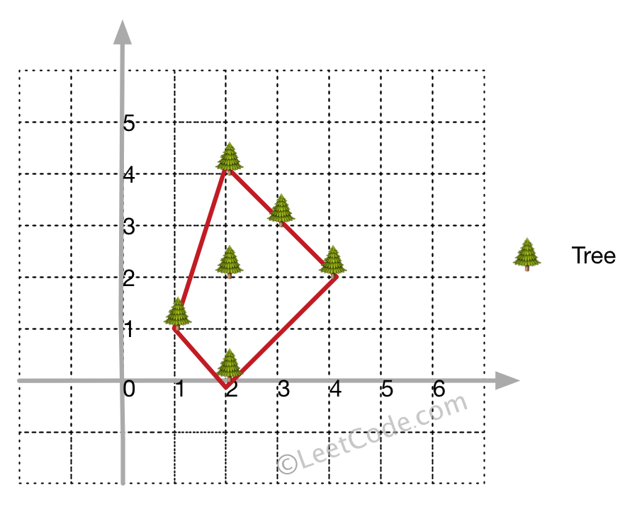

**Example 2:**

**Input:** [[1,2],[2,2],[4,2]]

**Output:** [[1,2],[2,2],[4,2]]

**Explanation:**

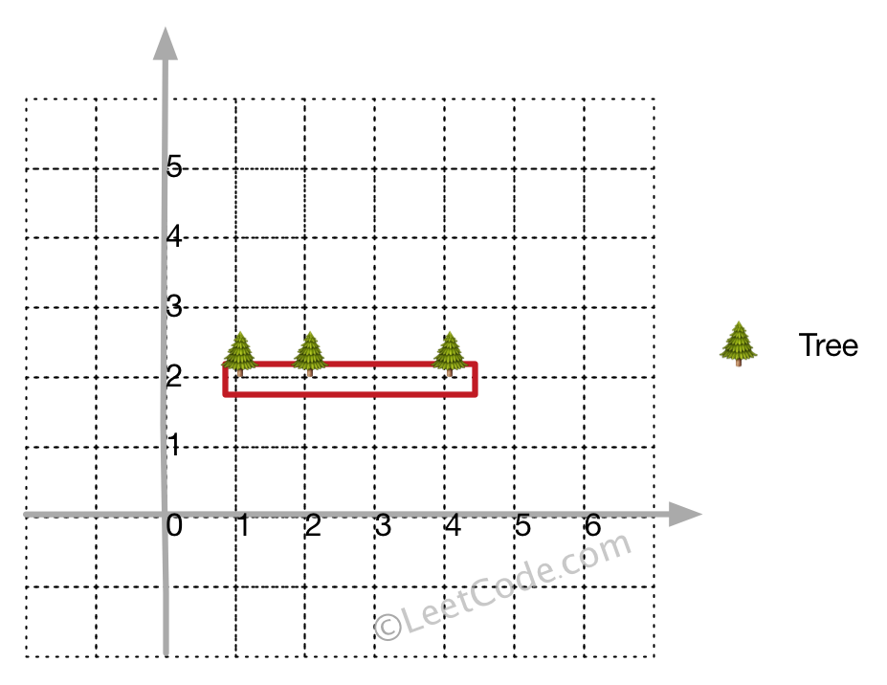

Even you only have trees in a line, you need to use rope to enclose them.

**Note:**

1. All trees should be enclosed together. You cannot cut the rope to enclose trees that will separate them in more than one group.
2. All input integers will range from 0 to 100.
3. The garden has at least one tree.
4. All coordinates are distinct.
5. Input points have **NO** order. No order required for output.
6. input types have been changed on April 15, 2019. Please reset to default code definition to get new method signature.

class Solution **{**

public**:**

vector**<**vector**<**int**>>** outerTrees**(**vector**<**vector**<**int**>>&** points**)** **{**

**if** **(**points**.**size**()** **<** 4**)** **return** points**;**

set**<**vector**<**int**>>** myset**;**

int left\_most **=** 0**,** n **=** points**.**size**();**

**for** **(**int i **=** 0**;** i **<** n**;** i**++)** **{**

**if** **(**points**[**i**][**0**]** **<** points**[**left\_most**][**0**])** **{**

left\_most **=** i**;**

**}**

**}**

int p **=** left\_most**;**

**do** **{**

int q **=** **(**p**+**1**)** **%** n**;** //只要不是p点皆可， 如(p+2) % n

**for** **(**int i **=** 0**;** i **<** n**;** i**++)** **{**

**if** **(**orientation**(**points**[**p**],** points**[**i**],** points**[**q**])** **<** 0**)** **{**

q **=** i**;**

**}**

**}**

**for** **(**int i **=** 0**;** i **<** n**;** i**++)** **{**

**if** **(**i **!=** p **&&** i **!=** q

**&&** orientation**(**points**[**p**],** points**[**i**],** points**[**q**])** **==** 0 **&&** inBetween**(**points**[**p**],** points**[**i**],** points**[**q**]))** **{**

myset**.**insert**(**points**[**i**]);**

**}**

**}**

myset**.**insert**(**points**[**q**]);**

p **=** q**;**

**}** **while** **(**p **!=** left\_most**);**

**return** vector**<**vector**<**int**>>** **(**myset**.**begin**(),** myset**.**end**());**

**}**

private**:**

int orientation**(**vector**<**int**>** **&**p**,** vector**<**int**>** **&**q**,** vector**<**int**>** **&**r**)** **{**

**return** **(**q**[**1**]-**p**[**1**])** **\*** **(**r**[**0**]-**q**[**0**])** **-** **(**q**[**0**]-**p**[**0**])** **\*** **(**r**[**1**]-**q**[**1**]);**

**}**

bool inBetween**(**vector**<**int**>** **&**p**,** vector**<**int**>** **&**i**,** vector**<**int**>** **&**q**)** **{**

bool a **=** i**[**0**]>=**p**[**0**]&&**i**[**0**]<=**q**[**0**] ||** i**[**0**]<=**p**[**0**]&&**i**[**0**]>=**q**[**0**];**

bool b **=** i**[**1**]>=**p**[**1**]&&**i**[**1**]<=**q**[**1**]** **||** i**[**1**]<=**p**[**1**]&&**i**[**1**]>=**q**[**1**];**

**return** a **&&** b**;**

**}**

**};**

### [588. Design In-Memory File System](https://leetcode-cn.com/problems/design-in-memory-file-system/)

Design an in-memory file system to simulate the following functions:

ls: Given a path in string format. If it is a file path, return a list that only contains this file's name. If it is a directory path, return the list of file and directory names **in this directory**. Your output (file and directory names together) should in **lexicographic order**.

mkdir: Given a **directory path** that does not exist, you should make a new directory according to the path. If the middle directories in the path don't exist either, you should create them as well. This function has void return type.

addContentToFile: Given a **file path** and **file content** in string format. If the file doesn't exist, you need to create that file containing given content. If the file already exists, you need to **append** given content to original content. This function has void return type.

readContentFromFile: Given a **file path**, return its **content** in string format.

**Example:**

**Input:**

["FileSystem","ls","mkdir","addContentToFile","ls","readContentFromFile"]

[[],["/"],["/a/b/c"],["/a/b/c/d","hello"],["/"],["/a/b/c/d"]]

**Output:**

[null,[],null,null,["a"],"hello"]

**Explanation:**

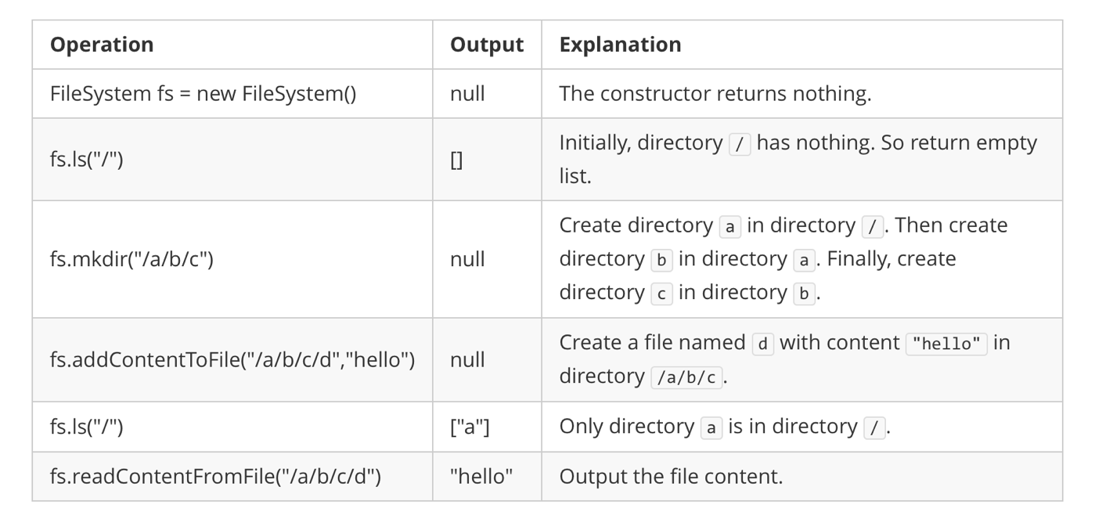

**Note:**

1. You can assume all file or directory paths are absolute paths which begin with / and do not end with / except that the path is just "/".
2. You can assume that all operations will be passed valid parameters and users will not attempt to retrieve file content or list a directory or file that does not exist.
3. You can assume that all directory names and file names only contain lower-case letters, and same names won't exist in the same directory.

class FileSystem {

public:

    FileSystem() {}

    vector<string> ls(string path) {

        auto p = f(path);

        if (!p->content.empty())

return {path.substr(path.rfind('/')+1)};

        vector<string> res;

        for (auto &i : p->dir) res.emplace\_back(i.first);

        return res;

    }

    void mkdir(string path) {

        f(path);

    }

    void addContentToFile(string path, string content) {

        auto p = f(path);

        p->content += content;

    }

    string readContentFromFile(string path) {

        auto p = f(path);

        return p->content;

    }

private:

    string content;

    map<string, FileSystem\*> dir;

    FileSystem \*f(string path) {

        for (auto &c : path) if (c == '/') c = ' ';

        stringstream ss(path);

        auto p = this;

        while (ss >> path) {

            if (!p->dir.count(path)) {

                p->dir[path] = new FileSystem();

            }

            p = p->dir[path];

        }

        return p;

    }

};

### 589. N-ary Tree Preorder Traversal

Easy

Given an n-ary tree, return the *preorder* traversal of its nodes' values.

*Nary-Tree input serialization is represented in their level order traversal, each group of children is separated by the null value (See examples).*

**Follow up:**

Recursive solution is trivial, could you do it iteratively?

**Example 1:**

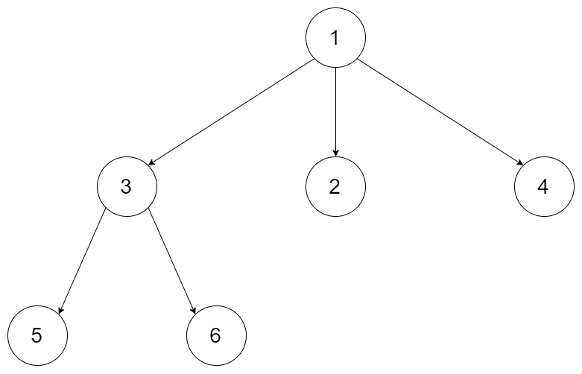

**Input:** root = [1,null,3,2,4,null,5,6]

**Output:** [1,3,5,6,2,4]

**Example 2:**



**Input:** root = [1,null,2,3,4,5,null,null,6,7,null,8,null,9,10,null,null,11,null,12,null,13,null,null,14]

**Output:** [1,2,3,6,7,11,14,4,8,12,5,9,13,10]

**Constraints:**

* The height of the n-ary tree is less than or equal to 1000
* The total number of nodes is between [0, 10^4]

/\*

// Definition for a Node.

class Node {

public:

int val;

vector<Node\*> children;

Node() {}

Node(int \_val, vector<Node\*> \_children) {

val = \_val;

children = \_children;

}

};

\*/

class Solution **{**

public**:**

vector**<**int**>** preorder**(**Node**\*** root**)** **{**

vector**<**int**>** res**;**

**if** **(!**root**)** **return** res**;**

stack**<**Node**\*>** stk**;**

stk**.**push**(**root**);**

**while** **(!**stk**.**empty**())** **{**

auto t **=** stk**.**top**();**

stk**.**pop**();**

res**.**push\_back**(**t**->**val**);**

**for** **(**int i **=** t**->**children**.**size**()-**1**;** i **>=** 0**;** **--**i**)** **{**

stk**.**push**(**t**->**children**[**i**]);**

**}**

**}**

**return** res**;**

**}**

**};**

### 590. N-ary Tree Postorder Traversal★

Easy

Given an n-ary tree, return the *postorder* traversal of its nodes' values.

*Nary-Tree input serialization is represented in their level order traversal, each group of children is separated by the null value (See examples).*

**Follow up:**

Recursive solution is trivial, could you do it iteratively?

**Example 1:**



**Input:** root = [1,null,3,2,4,null,5,6]

**Output:** [5,6,3,2,4,1]

**Example 2:**



**Input:** root = [1,null,2,3,4,5,null,null,6,7,null,8,null,9,10,null,null,11,null,12,null,13,null,null,14]

**Output:** [2,6,14,11,7,3,12,8,4,13,9,10,5,1]

**Constraints:**

* The height of the n-ary tree is less than or equal to 1000
* The total number of nodes is between [0, 10^4]

class Solution {

public:

vector<int> postorder(Node\* p) {

if (!p) return {};

stack<pair<Node\*, size\_t>> stk;

vector<int> res;

stk.emplace(p, 0);

while (!stk.empty()) {

auto &[p, index] = stk.top();

if (index == p->children.size()) {

res.push\_back(p->val);

stk.pop();

} else {

stk.emplace(p->children[index++], 0);

}

}

return res;

}

};

### 591. Tag Validator★

Hard

Given a string representing a code snippet, you need to implement a tag validator to parse the code and return whether it is valid. A code snippet is valid if all the following rules hold:

1. The code must be wrapped in a **valid closed tag**. Otherwise, the code is invalid.
2. A **closed tag** (not necessarily valid) has exactly the following format : <TAG\_NAME>TAG\_CONTENT</TAG\_NAME>. Among them, <TAG\_NAME> is the start tag, and </TAG\_NAME> is the end tag. The TAG\_NAME in start and end tags should be the same. A closed tag is **valid** if and only if the TAG\_NAME and TAG\_CONTENT are valid.
3. A **valid** TAG\_NAME only contain **upper-case letters**, and has length in range [1,9]. Otherwise, the TAG\_NAME is **invalid**.
4. A **valid** TAG\_CONTENT may contain other **valid closed tags**, **cdata** and any characters (see note1) **EXCEPT** unmatched <, unmatched start and end tag, and unmatched or closed tags with invalid TAG\_NAME. Otherwise, the TAG\_CONTENT is **invalid**.
5. A start tag is unmatched if no end tag exists with the same TAG\_NAME, and vice versa. However, you also need to consider the issue of unbalanced when tags are nested.
6. A < is unmatched if you cannot find a subsequent >. And when you find a < or </, all the subsequent characters until the next > should be parsed as TAG\_NAME (not necessarily valid).
7. The cdata has the following format : <![CDATA[CDATA\_CONTENT]]>. The range of CDATA\_CONTENT is defined as the characters between <![CDATA[ and the **first subsequent** ]]>.
8. CDATA\_CONTENT may contain **any characters**. The function of cdata is to forbid the validator to parse CDATA\_CONTENT, so even it has some characters that can be parsed as tag (no matter valid or invalid), you should treat it as **regular characters**.

**Valid Code Examples:**

**Input:** "<DIV>This is the first line <![CDATA[<div>]]></DIV>"

**Output:** True

**Explanation:**

The code is wrapped in a closed tag : <DIV> and </DIV>.

The TAG\_NAME is valid, the TAG\_CONTENT consists of some characters and cdata.

Although CDATA\_CONTENT has unmatched start tag with invalid TAG\_NAME, it should be considered as plain text, not parsed as tag.

So TAG\_CONTENT is valid, and then the code is valid. Thus return true.

**Input:** "<DIV>>> ![cdata[]] <![CDATA[<div>]>]]>]]>>]</DIV>"

**Output:** True

**Explanation:**

We first separate the code into : start\_tag|tag\_content|end\_tag.

start\_tag -> **"<DIV>"**

end\_tag -> **"</DIV>"**

tag\_content could also be separated into : text1|cdata|text2.

text1 -> **">> ![cdata[]] "**

cdata -> **"<![CDATA[<div>]>]]>"**, where the CDATA\_CONTENT is **"<div>]>"**

text2 -> **"]]>>]"**

The reason why start\_tag is NOT **"<DIV>>>"** is because of the rule 6.

The reason why cdata is NOT **"<![CDATA[<div>]>]]>]]>"** is because of the rule 7.

**Invalid Code Examples:**

**Input:** "<A> <B> </A> </B>"

**Output:** False

**Explanation:** Unbalanced. If "<A>" is closed, then "<B>" must be unmatched, and vice versa.

**Input:** "<DIV> div tag is not closed <DIV>"

**Output:** False

**Input:** "<DIV> unmatched < </DIV>"

**Output:** False

**Input:** "<DIV> closed tags with invalid tag name <b>123</b> </DIV>"

**Output:** False

**Input:** "<DIV> unmatched tags with invalid tag name </1234567890> and <CDATA[[]]> </DIV>"

**Output:** False

**Input:** "<DIV> unmatched start tag <B> and unmatched end tag </C> </DIV>"

**Output:** False

**Note:**

1. For simplicity, you could assume the input code (including the **any characters** mentioned above) only contain letters, digits, '<','>','/','!','[',']' and ' '.

class Solution {

public:

    bool f(const string &code, int &i, string &t) {

      while (i < code.size() && code[i] != '>') {

          if (!isupper(code[i])) return false;

          t += code[i++];

        }

        if (i == code.size()  || code[i] != '>') return false;

        if (t.size() < 1 || t.size() > 9) return false;

        return true;

    }

    bool isValid(string code) {

      int n = code.size();

      stack<string> stk;

      for (int i = 0; i < n; ++i) {

        if (code[i] == '<') {

          if (code[++i] == '/') {

            string t;

            if (!f(code, ++i, t)) return false;

            if (stk.empty() || stk.top() != t) return false;

            stk.pop();

            if (stk.empty() && i != n-1) return false;

          }

          else if (code[i] == '!') {

            if (stk.empty()) return false;

            auto p = code.find("![CDATA[" , i);

            auto q = code.find("]]>" , i);

            if (p != i || q == string::npos) return false;

            i = q+2;

          }

          else {

            string t;

            if (!f(code, i, t)) return false;

            stk.push(t);

          }

        }

        else if (stk.empty()) return false;

      }

      return stk.empty();

    }

};

class Solution {

public:

    bool isValid(string code) {

        regex cdata("<!\\[CDATA\\[.\*?\\]\\]>");

regex tag("<([A-Z]{1,9})>[^<]\*</\\1>");

        code = regex\_replace(code, cdata, "c");

        string pre = code;

        while (pre != (code = regex\_replace(code, tag, "t"))) pre=code;

        return "t" == code;

    }

};

### 592. Fraction Addition and Subtraction

Medium

Given a string representing an expression of fraction addition and subtraction, you need to return the calculation result in string format. The final result should be [irreducible fraction](https://en.wikipedia.org/wiki/Irreducible_fraction). If your final result is an integer, say 2, you need to change it to the format of fraction that has denominator 1. So in this case, 2 should be converted to 2/1.

**Example 1:**

**Input:**"-1/2+1/2"

**Output:** "0/1"

**Example 2:**

**Input:**"-1/2+1/2+1/3"

**Output:** "1/3"

**Example 3:**

**Input:**"1/3-1/2"

**Output:** "-1/6"

**Example 4:**

**Input:**"5/3+1/3"

**Output:** "2/1"

**Note:**

1. The input string only contains '0' to '9', '/', '+' and '-'. So does the output.
2. Each fraction (input and output) has format ±numerator/denominator. If the first input fraction or the output is positive, then '+' will be omitted.
3. The input only contains valid **irreducible fractions**, where the **numerator** and **denominator** of each fraction will always be in the range [1,10]. If the denominator is 1, it means this fraction is actually an integer in a fraction format defined above.
4. The number of given fractions will be in the range [1,10].
5. The numerator and denominator of the **final result** are guaranteed to be valid and in the range of 32-bit int.

class Solution **{**

public**:**

string fractionAddition**(**string expression**)** **{**

istringstream in**(**expression**);**

int A **=** 0**,** B **=** 1**,** a**,** b**;**

char \_**;**

**while** **(**in **>>** a **>>** \_ **>>** b**)** **{**

A **=** A **\*** b **+** a **\*** B**;**

B **\*=** b**;**

int g **=** abs**(**\_\_gcd**(**A**,** B**));**

A **/=** g**;**

B **/=** g**;**

**}**

**return** to\_string**(**A**)** **+** '/' **+** to\_string**(**B**);**

**}**

**};**

### 593. Valid Square

Medium

Given the coordinates of four points in 2D space, return whether the four points could construct a square.

The coordinate (x,y) of a point is represented by an integer array with two integers.

**Example:**

**Input:** p1 = [0,0], p2 = [1,1], p3 = [1,0], p4 = [0,1]

**Output:** True

Note:

1. All the input integers are in the range [-10000, 10000].
2. A valid square has four equal sides with positive length and four equal angles (90-degree angles).
3. Input points have no order.

class Solution {

public:

    bool validSquare(vector<int>& p1, vector<int>& p2, vector<int>& p3, vector<int>& p4) {

        vector<vector<int>> p{p1, p2, p3, p4};

        sort(p.begin(), p.end());

        int len0 = dist(p[0], p[1]), len1 = dist(p[1], p[3]),

len2 = dist(p[3], p[2]), len3 = dist(p[2], p[0]);

        return len0 == len1 && len1 == len2 && len2 == len3

             && len0 != 0 && dist(p[0], p[3]) == dist(p[1], p[2]);

    }

private:

    double dist(vector<int> &p1, vector<int> &p2) {

        int a = p2[1] - p1[1], b = p2[0] - p1[0];

        return a\*a + b\*b;

    }

};

### 594. Longest Harmonious Subsequence

Easy

We define a harmounious array as an array where the difference between its maximum value and its minimum value is **exactly** 1.

Now, given an integer array, you need to find the length of its longest harmonious subsequence among all its possible [subsequences](https://en.wikipedia.org/wiki/Subsequence).

**Example 1:**

**Input:** [1,3,2,2,5,2,3,7]

**Output:** 5

**Explanation:** The longest harmonious subsequence is [3,2,2,2,3].

**Note:** The length of the input array will not exceed 20,000.

class Solution **{**

public**:**

int findLHS**(**vector**<**int**>&** nums**)** **{**

unordered\_map**<**int**,** int**>** mp**;**

**for** **(**auto **&**i **:** nums**)** mp**[**i**]++;**

int res **=** 0**;**

**for** **(**auto **&**i **:** mp**)** **if** **(**mp**.**count**(**i**.**first**-**1**))** **{**

res **=** max**(**res**,** i**.**second **+** mp**[**i**.**first**-**1**]);**

**}**

**return** res**;**

**}**

**};**

### [595. Big Countries](https://leetcode-cn.com/problems/big-countries/)(SQL)

SQL架构

There is a table World

+-----------------+------------+------------+--------------+---------------+

| name | continent | area | population | gdp |

+-----------------+------------+------------+--------------+---------------+

| Afghanistan | Asia | 652230 | 25500100 | 20343000 |

| Albania | Europe | 28748 | 2831741 | 12960000 |

| Algeria | Africa | 2381741 | 37100000 | 188681000 |

| Andorra | Europe | 468 | 78115 | 3712000 |

| Angola | Africa | 1246700 | 20609294 | 100990000 |

+-----------------+------------+------------+--------------+---------------

A country is big if it has an area of bigger than 3 million square km or a population of more than 25 million.

Write a SQL solution to output big countries' name, population and area.

For example, according to the above table, we should output:

+--------------+-------------+--------------+

| name | population | area |

+--------------+-------------+--------------+

| Afghanistan | 25500100 | 652230 |

| Algeria | 37100000 | 2381741 |

+--------------+-------------+--------------+

select name, population, area

from World

where area > 3000000 or population > 25000000

### [596. Classes More Than 5 Students](https://leetcode-cn.com/problems/classes-more-than-5-students/)(SQL)

SQL架构

There is a table courses with columns: **student** and **class**

Please list out all classes which have more than or equal to 5 students.

For example, the table:

+---------+------------+

| student | class |

+---------+------------+

| A | Math |

| B | English |

| C | Math |

| D | Biology |

| E | Math |

| F | Computer |

| G | Math |

| H | Math |

| I | Math |

+---------+------------+

Should output:

+---------+

| class |

+---------+

| Math |

+---------+

**Note:**  
The students should not be counted duplicate in each course.

select class

from courses

group by class

having count(distinct student) >= 5;

### [597. Friend Requests I: Overall Acceptance Rate](https://leetcode-cn.com/problems/friend-requests-i-overall-acceptance-rate/)(SQL)

SQL架构

In social network like Facebook or Twitter, people send friend requests and accept others’ requests as well. Now given two tables as below:

Table: friend\_request

| sender\_id | send\_to\_id |request\_date|

|-----------|------------|------------|

| 1 | 2 | 2016\_06-01 |

| 1 | 3 | 2016\_06-01 |

| 1 | 4 | 2016\_06-01 |

| 2 | 3 | 2016\_06-02 |

| 3 | 4 | 2016-06-09 |

Table: request\_accepted

| requester\_id | accepter\_id |accept\_date |

|--------------|-------------|------------|

| 1 | 2 | 2016\_06-03 |

| 1 | 3 | 2016-06-08 |

| 2 | 3 | 2016-06-08 |

| 3 | 4 | 2016-06-09 |

| 3 | 4 | 2016-06-10 |

Write a query to find the overall acceptance rate of requests rounded to 2 decimals, which is the number of acceptance divide the number of requests.

For the sample data above, your query should return the following result.

|accept\_rate|

|-----------|

| 0.80|

**Note:**

* The accepted requests are not necessarily from the table friend\_request. In this case, you just need to simply count the total accepted requests (no matter whether they are in the original requests), and divide it by the number of requests to get the acceptance rate.
* It is possible that a sender sends multiple requests to the same receiver, and a request could be accepted more than once. In this case, the ‘duplicated’ requests or acceptances are only counted once.
* If there is no requests at all, you should return 0.00 as the accept\_rate.

**Explanation:** There are 4 unique accepted requests, and there are 5 requests in total. So the rate is 0.80.

**Follow-up:**

* Can you write a query to return the accept rate but for every month?
* How about the cumulative accept rate for every day?

select

    round(

        ifnull(

            (select count(\*) from (select distinct requester\_id, accepter\_id from request\_accepted) as A)

            / (select count(\*) from (select distinct sender\_id, send\_to\_id from friend\_request) as B)

        , 0)

    , 2) as accept\_rate;

### 598. Range Addition II

Easy

Given an m \* n matrix **M** initialized with all **0**'s and several update operations.

Operations are represented by a 2D array, and each operation is represented by an array with two **positive** integers **a** and **b**, which means **M[i][j]** should be **added by one** for all **0 <= i < a** and **0 <= j < b**.

You need to count and return the number of maximum integers in the matrix after performing all the operations.

**Example 1:**

**Input:**

m = 3, n = 3

operations = [[2,2],[3,3]]

**Output:** 4

**Explanation:**

Initially, M =

[[0, 0, 0],

[0, 0, 0],

[0, 0, 0]]

After performing [2,2], M =

[[1, 1, 0],

[1, 1, 0],

[0, 0, 0]]

After performing [3,3], M =

[[2, 2, 1],

[2, 2, 1],

[1, 1, 1]]

So the maximum integer in M is 2, and there are four of it in M. So return 4.

**Note:**

1. The range of m and n is [1,40000].
2. The range of a is [1,m], and the range of b is [1,n].
3. The range of operations size won't exceed 10,000.

class Solution **{**

public**:**

int maxCount**(**int m**,** int n**,** vector**<**vector**<**int**>>&** ops**)** **{**

**for** **(**auto **&**v **:** ops**)** **{**

m **=** min**(**m**,** v**[**0**]);**

n **=** min**(**n**,** v**[**1**]);**

**}**

**return** n**\***m**;**

**}**

**};**

### 599. Minimum Index Sum of Two Lists

Easy

Suppose Andy and Doris want to choose a restaurant for dinner, and they both have a list of favorite restaurants represented by strings.

You need to help them find out their **common interest** with the **least list index sum**. If there is a choice tie between answers, output all of them with no order requirement. You could assume there always exists an answer.

**Example 1:**

**Input:**

["Shogun", "Tapioca Express", "Burger King", "KFC"]

["Piatti", "The Grill at Torrey Pines", "Hungry Hunter Steakhouse", "Shogun"]

**Output:** ["Shogun"]

**Explanation:** The only restaurant they both like is "Shogun".

**Example 2:**

**Input:**

["Shogun", "Tapioca Express", "Burger King", "KFC"]

["KFC", "Shogun", "Burger King"]

**Output:** ["Shogun"]

**Explanation:** The restaurant they both like and have the least index sum is "Shogun" with index sum 1 (0+1).

**Note:**

1. The length of both lists will be in the range of [1, 1000].
2. The length of strings in both lists will be in the range of [1, 30].
3. The index is starting from 0 to the list length minus 1.
4. No duplicates in both lists.

class Solution **{**

public**:**

vector**<**string**>** findRestaurant**(**vector**<**string**>&** list1**,** vector**<**string**>&** list2**)** **{**

unordered\_map**<**string**,** int**>** mp**;**

**for** **(**int i **=** 0**;** i **<** list1**.**size**();** **++**i**)** mp**[**list1**[**i**]]** **=** i**;**

int sum **=** INT\_MAX**;**

vector**<**string**>** res**;**

**for** **(**int i **=** 0**;** i **<** list2**.**size**();** **++**i**)** **{**

**if** **(**mp**.**count**(**list2**[**i**]))** **{**

int cnt **=** i **+** mp**[**list2**[**i**]];**

**if** **(**cnt **<** sum**)** **{**

res**.**clear**();**

res**.**push\_back**(**list2**[**i**]);**

sum **=** cnt**;**

**}**

**else** **if** **(**cnt **==** sum**)** res**.**push\_back**(**list2**[**i**]);**

**}**

**}**

**return** res**;**

**}**

**};**

### 600. Nonnegative Integers without Consecutive Ones★★

Hard

Given a positive integer n, find the number of **non-negative** integers less than or equal to n, whose binary representations do NOT contain **consecutive ones**.

**Example 1:**

**Input:** 5

**Output:** 5

**Explanation:**

Here are the non-negative integers <= 5 with their corresponding binary representations:

0 : 0

1 : 1

2 : 10

3 : 11

4 : 100

5 : 101

Among them, only integer 3 disobeys the rule (two consecutive ones) and the other 5 satisfy the rule.

**Note:** 1 <= n <= 109

class Solution {

public:

    int findIntegers(int num) {

        int len = 1;

        while (num >> len) ++len;

        vector<int> f(len + 1, 0);

        f[0] = 1; f[1] = 2;

        for (int i = 2; i <= len; i++) f[i] = f[i-1] + f[i-2];

        return helper(num, f);

    }

    int helper(int num, const vector<int> &f) {

        if (num <= 1) return num + 1;

        int len = 1;

        while (num >> len) ++len;

        //11开头

        if (num >> (len-2) == 3) return f[len];

        else {

            int temp = (1<<(len - 1)) - 1;

            return f[len - 1] + helper(temp&num, f);

        }

    }

};